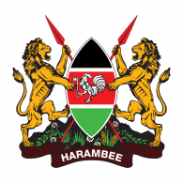
REPUBLIC OF KENYA
MINISTRY OF HEALTH
KHHRAC

KENYA NATIONAL HEALTH WORKFORCE ACCOUNTS

Report of NHWA Implementation | AUGUST 2022

Supported by:
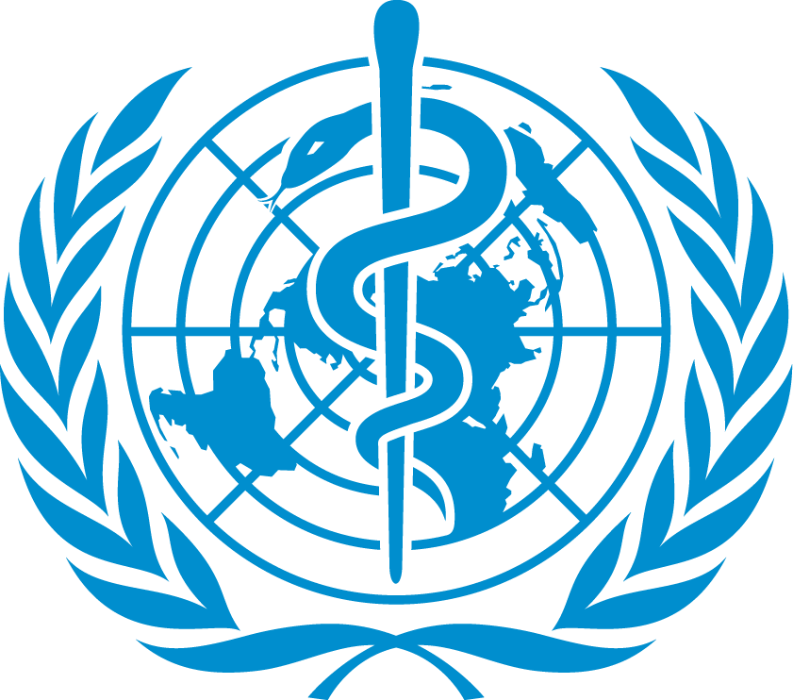

EXECUTIVE SUMMARY

The strategic focus of the health sector has been defined in the Kenya Health Policy 2014 – 2030 that demonstrates its commitment, under government stewardship, to ensure that the Country attains the highest possible standards of health, in a manner responsive to the needs of the population. The delivery of quality health services to attain these standards is dependent on the availability, accessibility, acceptability of a health workforce that meets the quality and expectations of the population. However, the availability of accurate, reliable and timely health workforce data has been a major challenge that has necessitated the utilization of non-linked diverse sources not geared to decision making.

This National Health Workforce Account (NHWA) report presents measures that Kenya has progressively implemented to establish the comprehensive health workforce status based on data being collected by the Kenya Health Human Resources Authority Council (KHHRAC). The KHHRAC was established under the Health Act 2017 with the mandate to advise the leadership on National and the respective County governments on Health Human Resources for Health (HRH) which is inclusive of recruitment, employment, deployment, recommendation on intergovernmental transfers, training, and remuneration.

The KHHRAC adopted a multisectoral approach and this report has several facets and health workforce characteristics from the different sectors. Considering the fact that all health professionals have to be registered and licensed to practice by their respective regulatory agencies regardless of whether the employer is in the public, faith-based or private sector, the regulatory bodies for a long time were the reliable source of data. It is important to note that the regulatory bodies have specific data sets of interest to their mandate and therefore not cover all the characteristics for decision making and policy development are adequately covered. The NHWA has provided a system that has facilitated the County Human Resource Managers to be able to improve the accuracy, reliability and the timeliness of the health workforce data.
The registration of health professionals has had an increasing trend. The ever-registered number of nurses rose from 79,307 in 2017 to 124,766 in 2021 and the number of nurses active in service in 57,446. The ever-registered medical practitioners are 14,207 while the ones in active service are 9,499. In the public sector, the number of health workforce is 87,236 (78,172 health professionals and 9,519 non-professionals and the total number of health professionals in the private sector from administrative sources is 108,802 and this adds up to 186,974.
It was that there is a large disparity in health workforce distribution across the country, which is influenced by demographics, number of health care facilities and whether the facilities are urban or rural. The skill mix of the health professionals is inadequate and this has impacted negatively the service delivery and unnecessary referrals.
Data indicated that some very key courses that play a key role in the provision of services directly or indirectly had minimum registration these are Biomedical Engineering, Pharmaceutical technologist and Physiotherapy. Majority of the mid-level professionals training institutions are public with the main courses offered being Nursing, Clinical Medicine, Community Development and Health Records Information.

FOREWARD

A health workforce (HWF) of adequate size and skill mix, as well as the required teachers and trainers, are critical to the attainment of any population health goal inclusive of the achievement of universal health coverage (UHC) (WHO 2017c) and the health-related targets of the United Nations Sustainable Development Goals (SDGs).

The Global Strategy on Human Resources for Health: Workforce 2030 (WHO 2016c), adopted by the 69th World Health Assembly in May 2016 under resolution WHA69.19, aims to ensure universal accessibility, acceptability, coverage and quality of health workforces within strengthened health systems. The achievement of this goal can mainly be achieved through adequate investments and the implementation of effective policies at national, regional and global levels.

Member States are urgently expected to strengthen or establish national health personnel information systems to collect and analyse reliable and up-to-date health workforce data. These data can help to assess the appropriateness and effectiveness of health workforce policies in the strategic plans for health.

The National Health Workforce Accounts (NHWA) system is envisaged to progressively improve the availability, quality, and use of data on health workforce (HWF) through the monitoring of a set of indicators to support achievement of UHC and Sustainable Development Goals (SDGs). In Kenya, the implementation process was initiated in 2019 under the leadership of the Ministry of Health by the Kenya Health Human Resources Advisory Council (KHHRAC) with technical support from WHO.

During the Conceptualization (framework & governance) and Operationalization, data sets and data collection mechanisms were identified in addition to establishing legal framework for operation.. A Multi sectoral approach was adopted following the Government buy-in considering that the health sector is inclusive of all the health and other related sectors whose actions contribute towards the attainment of the Health Goals. The other stakeholders are the Ministries of National Treasury, Education, Labour, Immigration and Public Service State Department, the Private sector, the Faith Based Consortium, Regulatory bodies, Civil society, Communities, Development Partners, the Health workers and Educational Institutions. `

The established Multi-Agency Stakeholders Forum has been providing oversight on the implementation process and conducting dialogue among its members on the findings of the data collected in response to the NHWA indicators to inform decision making and policy development. The multisectoral approach has provided a platform were cross-cutting matters affecting the welfare of the health workforce are discussed and synergistic solutions and strategies are identified that will promote public, private partnerships and implementations while others are scaled up to the leadership for direction.

On the basis of the aforementioned, the health sector has been able to able to determine the accurate and reliable availability of health workforce in addition to establishing the quality of the health workforce for the provision of quality and equitable service delivery across all the sectors in all the geographic regions.

ACKNOWLEDGEMENT

The National Health Workforce (NHWA) Report 2021 has been prepared to share, guide and provide policy makers in the Government, Development Partners and other stakeholders with key information on the status of health workforce in Kenya to help in the development of appropriate policies as well as in resource allocation.

The preparation of this Report would not have been possible without the support, hard work, and endless efforts of the dedicated team of the Secretariat drawn from the Kenya Health Human Resource Advisory Council (KHHRAC), relevant Ministry of Health departments, Ministry of Labour, State Department of Immigration, Public Service County Health departments, the Kenya Health Professional Oversight Authority (KHPOA), the regulatory bodies among other institutions within the health sector. The National Secretariat led by the National Health Workforce (NHWA) Account Focal Person, Dr. Mutile Wanyee included, Steve Muneene - the NHWA Data Clerk, Jeniffer Kiema (DHRM&D), Anne Marimbet MOH Admin), Jane Otoko MOH (ICT), Dr. David Soti (DG’s Office), Dr Amos Oyoko (MOH Norms & Standards), Sam Kamau (KHHRAC), Rachel Githiomi (MOH Research), Julius Mutiso ( Health Care Financing), Meldah Angir (Labour), Dr. James Kiarie and Monica Ngugi (CUE), David Peter Ogolla (Immigration), David Wambua (KHPOA) and McAfullo Ochieng (Referral &Teaching Hospitals). The Secretariat has Regional County representation, Rachel Tikani (South Rift), Njeru (Lower Central) Eastern), Anne Maina (Upper Central), Josephine Kakai (Coastal), Ibrahim Mohammed (North Eastern), Tabitha Katiwa (Nairobi and Eastern), Philomen Illah (Lake basin).

The implementation of the NHWA was with financial support from the Ministry of Health, the World Health Organization (WHO) both the Kenya country and the AFRO regional office, the Public Finance Management Reforms Secretariat (PFMRS) at the National Treasury and the Health IT, USAID among other key stakeholders. The technical assistance was solely from the WHO and the KHHRAC Secretariat.

I sincerely would like to thank the whole team for working tirelessly to ensure the Report was completed on time. The compilation of this Report would not have been successful without the professional input and dedication of the Technical Working Group and the secretariat that was coordinated by both Dr Annah Wamae, the former Acting Chief Executive Office, Kenya Health Human Resource Advisory Council whose tireless effort was carried on seamlessly by the current Acting Chief Executive Office, Dr John Kihama

We are particularly grateful to the entire Report writing team for their invaluable contributions that made this exercise a success. We would also like to express special gratitude to our development partners who found time to participate in the entire process.

Special thanks go to the County Human Resources for Health Managers (CHRM) and County Health Records and Information officers (CHRIO) for providing data in real time for this report with the committed guidance of the County Chief Officers of Health under the auspices of the Council of Governors (CoG).

MARY MUTHONI

PRINCIPAL SECRETARY

CONTENTS

FOREWORD

ACKNOWLEDGEMENTS

EXECUTIVE SUMMARY

Chapter One: INTRODUCTION

Chapter Two: HEALTH WORKFORCE

Chapter Three: IMPLEMENTATION OF THE NATIONAL HEALTH WORKFORCE ACCOUNTS

Chapter Four: DATA COMPILATION AND ANALYSIS

Chapter Five: HEALTH LABOUR MARKET FLOWS
Chapter Six: EDUCATION AND TRAINING
Chapter Seven: SERVING POPULATION NEEDS

Abbreviations
CDACC Curriculum Development, Assessment and Certification Council
CHAK Christian Health Association of Kenya
CUE Commission for University Education
HENNET Health NGOs Network
HWF Health Workforce
KCCB Kenya Conference of Catholic Bishops
KEMRI Kenya Medical Research Institute
KFBHSC Kenya Faith Based Health Services Consortium
KHPOA Kenya Health Professions Oversight Authority
KMTC Kenya Medical Training College
KNH Kenyatta National Hospital
KNQA Kenya National Qualifications Authority
KUCCPS Kenya Universities and Colleges Central Placement Service
KUTRRH Kenyatta University Teaching Research and Referral Hospital
MEDS Mission for Essential Drugs and Supplies
MNTRH Mathari National Teaching & Referral Hospital
MTRH Moi Teaching and Referral Hospital
NHWA National Health Workforce Account
SAGAs Semi-Autonomous Government Agencies
SUPKEM Supreme Council of Kenya Muslims
TVETA Technical and Vocational Education and Training Authority

CHAPTER ONE:
INTRODUCTION
1.0 COUNTRY CONTEXT

1.0.1 Geographic

Kenya is situated in the eastern part of the African continent. The equator passes at the middle, separating the upper and lower parts almost equally. Kenya borders Ethiopia (north), Somalia (northeast), Tanzania (south), Uganda (west), and South Sudan (northwest). The Indian Ocean is on the eastern side. The country is administratively divided into 47 counties

Kenya has a total of 582,646 square kilometres, of which 571,466 square kilometres is covered by dry land. Most of the land area (80 percent) is arid or semi-arid, and only 20 percent is arable. The country falls within two regions: lowlands, comprised of the coastal and lake region and highlands, which are situated on both sides of the Great Rift Valley. Rainfall and temperatures are influenced by altitude and proximity to the Indian Ocean. The coastal region has a tropical climate, with both rainfall and temperatures higher than the rest of the country throughout the year.

1.0.2 Economy

The Kenyan economy is predominantly agricultural with a strong industrial base. The performance of the Kenyan economy since the country gained independence has been mixed. Recent years have seen an estimated 5-6 percent growth. On the demand side, growth has mainly been driven by an increase in private consumption and rapid growth in capital investment. On the supply side, the major drivers of the economy have been agriculture, forestry, and fishing; construction; wholesale and retail trade; education; and finance and insurance.
1.0.3 Key Country indicators
World Bank income group | Lower-middle-income
Child health
Infants exclusively breastfed for the first six months of life (%) (2022 )** | 60
Diphtheria tetanus toxoid and pertussis (DTP3) immunization coverage among 1-year-olds (%) (2022)** | 89.2
Demographic and socioeconomic statistics
Population (2022) | 50,622,914*
Population per km²: | 92.65
% Population under 15 (2020) | 38.59
% Population over 60 (2020) | 4.5
Life expectancy at birth (years) (2020) | 66.9 (Both sexes)  66.5 years (Female)  60.6 years (Male)
Males/Females: | 49.5%: 50.5%*
Crude Birthrate: ‰ | 27.7 **
Crude Deathrate: ‰ | 10.5*
Literacy rate among adults aged >= 15 years (%) (2020-2021) | 81.5
Gender Inequality Index rank (2020) | 95 (USAID)
Human Development Index rank (2020) | 143 (UNDP)
Health systems

Total expenditure on health as a percentage of gross domestic product (2020) | 4.6
Private expenditure on health as a percentage of total expenditure on health (2020) | 35.5
General government expenditure on health as a percentage of total government expenditure (2020) | 6.7 (MOH)
Physicians’ density (per 10,000 population) (2020) | 1.56
Nursing and midwifery personnel density (per 10,000 population) (2020) | 1.2
Mortality and global health estimates
(2015)
Neonatal mortality rate (per 1000 live births)** | 21
Infant mortality rate**(per 1000 live births) | 32
Under-five mortality rate (per 1000 live births -2022) ** | 41
Maternal mortality ratio (per 100 000 live births) (2019) * | 355
Births attended by skilled health personnel (%) (2022) ** | 89.3
Public health and environment
Population using improved drinking water sources (%) (2019)* | 64.8
Population using improved sanitation facilities (%) (2019)* | 82.5
1.0.4 Evolution of Health Indicators
INDICATOR | 2010 | 2014 | 2017 | 2018 | 2019 | 2020
Life expectancy (years) WB | F 62.9  M 58,9 | F 66.4  M 61.8 | F 68.2  M 63.5 | F 68.6  M 63.9 | F 69.05  M 64.3 | F 69.4  M 64.6
HIV prevalence (% population 15-49) UNAIDs | 5.7% | 5.2% | 4.7% | 4.5% | 4.4% | 4.2%
Incidence of Tuberculosis (per 100,000 people) WHO | 531 | 423 | 319 | 292 | 262 | 259
Malaria incidence rate (per 1,000 people at risk) WHO | 64 | 70.7 | 62.5 | 59.7 | 56.5 | 50.9
Mortality rate due to NCD (% of total) | 29 | 35 | 39 |  | 41
% of population with piped and non-piped drinking water | 29.5 | 33.5 | 35.9
Children under 5 years, moderately or severely stunted (‘000’) | 2,504. | 2,342 | 1,842
*KPHC; **DHS 2022

1.0.5 Population Pyramid 2020
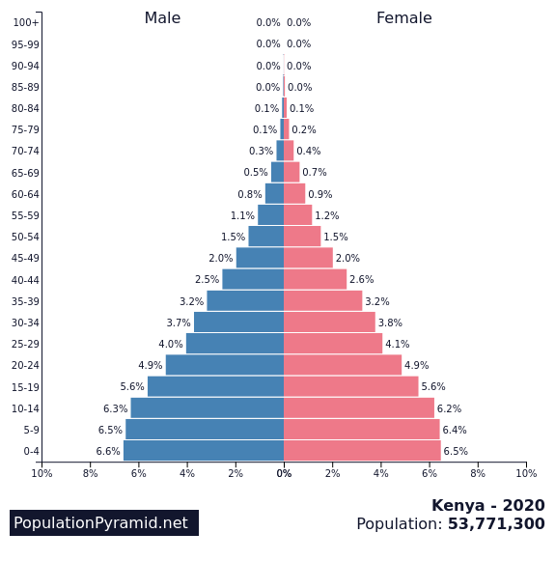
As of midyear 2020, Kenya had a population of 53.7 million, with an annual population growth rate of 2.36%, and 39% of Kenya’s population was under age 15. The Total Fertility Rate, has been declining progressively from 6.1 in 1990 to 4.4 in 2015 and to 3.4% in 2020. 44.6% of all women aged 15 to 49 and 60.7% of married women used a modern contraceptive method.
1.0.6 Political Characteristics
Kenya is a sovereign republic with a multi-party democratic system with two levels of Government i.e., National Government and County Government. The two levels of government are inter-dependent and distinct and the functions of the National Government and those of the County Governments are clearly stipulated in the Fourth schedule of the Constitution. There are three arms of government; Executive; Legislature and the Judiciary. The Executive is the arm of government that implements Government Laws and Policies and it exists at both the National Government and County Government.
The Constitution of Kenya 2010 establishes a legislature that is fundamentally different (in terms of structure, membership and powers) that exists at both the national and county level. In Article 235 the staffing of County Governments is the responsibility of the county government within the framework of uniform norms and standards prescribed by the Act of Parliament, and this entails the
- Establishment and abolishing offices in its public service;
- Appointment of persons to hold or act in those offices, in addition to confirming these appointments; and
- Exercising disciplinary control including the removal of persons holding or acting in those offices.
Article 1 of the Constitution states that all the sovereign power belongs to the people of Kenya, but it is delegated, at the national level, to the executive, the judiciary and parliament. These three arms of government also have the power to exercise this sovereign power at the county level.
1.2.0 HEALTH SYSTEMS SET-UP, PROFILE OF HEALTH SERVICES AND HEALTH
FACILITIES

1.2.1 Health under the Devolved System of Government
The most significant feature of the Constitution of Kenya 2010 is the introduction of a devolved system of government, which provides for one (1) national government and forty-seven (47) county governments. Governance structures fundamentally changed in 2013 from a previously centralized structure to a two-tier system comprising the National Government and 47 devolved County Governments.
In observance of this provision, the Kenya Health Policy 2014−2030 takes into account the objectives of devolution, which include the following:
- The promotion of democracy and accountability in the delivery of healthcare;
- Fostering of seamless service delivery during and after the transition period;
- Facilitating powers of self-governance to the people and enhancing their participation in making decisions on matters of health affecting them;
- Recognising the right of communities to manage their own health affairs and to further their development;
- Protection and promotion of the health interests and rights of minorities and marginalised communities, including informal settlements such as slum dwellers and under-served populations;
- Promotion of social and economic development and the provision of proximate, easily accessible health services throughout Kenya;
- Ensuring equitable sharing of national and local resources targeting health delivery throughout Kenya;
- Enhancing capacities of the two levels of governments to effectively deliver health services in accordance with their respective mandates;
- Facilitating the decentralization of state organs responsible for health, their functions and services from the capital of Kenya
- Enhancing checks and balances and the separation of powers between the two levels of government in delivery of health care
Specific functions are assigned to the two levels of governments with the National government providing leadership in health policy development; management of national referral health facilities; capacity building and technical assistance to counties; and consumer protection, including the development of norms, standards and guidelines.
County governments are responsible for health services delivery, including management of the county health facilities and pharmacies; ambulance services; promotion of primary healthcare; licensing and control of undertakings that sell food to the public; cemeteries, funeral parlours and crematoria; and refuse removal, refuse dumps, and solid waste disposal.
1.2.2 Organisation of Healthcare Service Delivery System
The health sector comprises of the public system, with major players being led by the MOH and parastatal organisations; the Private sector; the NGO sector, and the FBO facilities. Health services are provided through a network of over -13,826 (9,696) health facilities countrywide. About 6,426 (46.4%) of these are owned by the public sector, 6,054 (43.7%) fall under ownership of the commercial private sector, and 1,031 is owned by Faith Based Organizations (FBOs), 63 Non-Governmental Organizations (NGOs) and Community Based Organizations (CBOs). The distribution of health facilities shows that the Ministry of Health accounts for 42.9 percent of the total health facilities in the country while private sector accounts for 37.8 percent.
The public health system consists of the following levels of health facilities:
The current structure consists of the following six levels:
- Level 1: Community
- Level 2: Dispensaries
- Level 3: Health centres
- Level 4: Primary referral facilities
- Level 5: Secondary referral facilities
- Level 6: Tertiary referral facilities
1.2.2.1 Community level

The community-based approach is the mechanism through which households and communities strengthen their role in health and health-related development by increasing their knowledge, skills and participation. Community level is the foundation of the service delivery priorities, because it allows the community to define its own priorities so as to develop ownership and commitment to health services.

1.2.2.2 Dispensaries
The dispensaries are at the lowest level of the public health system and are the first point of contact with patients. They are staffed by enrolled nurses, public health technicians, and dressers (medical assistants). The enrolled nurses provide antenatal care and treatment for simple medical problems during pregnancy such as anaemia, and occasionally conduct normal deliveries. Enrolled nurses also provide basic outpatient curative care.
1.2.2.3 Health Centres
Health centres are staffed with midwives and nurses, clinical officers, and occasionally with doctors. They provide a wider range of services, such as basic curative and preventive services for adults and children, as well as reproductive health services. They also conduct minor surgical services such as incision and drainage. They augment their service coverage with outreach services, and refer severe and complicated conditions to the appropriate level, such as the district hospital.
1.2.2.4 County Referral hospitals
County referral hospitals are the facilities for clinical care at the district level. They are the first referral hospital and form an integral part of the county health system.
A County referral hospital provides the following:
- Curative and preventive care and promotion of health of the people in the district;
- Quality clinical care by a more skilled and competent staff than those of the health centres and dispensaries;

- Laboratory and other diagnostic techniques appropriate to the medical, surgical, and outpatient activities of the district hospital;
- Inpatient care until the patient can go home or back to the health centre;
- Training and technical supervision to health centres, as well as resource centre for health centres at each district hospital;
- Twenty-four-hour services;
- The following ot-patient clinical services:
  - Obstetrics and Gynaecology;
  - Child health;
  - Medicine;
  - Surgery, including anaesthesia;
- Accident and emergency services;

- Referral services;

1.2.2.5 Regional referral Hospitals (Level 5)
They provide specialized care, involving skills and competence not available at county hospitals, which makes them the next level of referral after County Referral hospitals. Their personnel include medical specialist professionals, such as general surgeons, general medical physicians, paediatricians, general and specialized nurses, midwives, and public health staff.
Regional hospitals are expected to provide clinical services in the following disciplines:
- Medicine;
- General surgery and anaesthesia;
- Paediatrics;
- Obstetrics and Gynaecology;
- Dental services;
- Psychiatry;
- Accident and emergency services;
- Ear, nose and throat;
- Ophthalmology;
- Dermatology;
- ICU (intensive care unit) and HDU (high dependency unit) services.
They should also provide the following services:
- Laboratory and diagnostic techniques for referrals from the lower levels of the health care system;
- Teaching and training for health care personnel such as nurses and medical officer interns;
- Supervision and monitoring of County hospital activities;

1.2.2.6 Teaching and Referral Hospitals
The Teaching and Referral Hospitals are centres of excellence and provide complex health care requiring more complex technology and highly skilled personnel. They have a high concentration of resources and are relatively expensive to run. They also support the training of health workers at both pre-service and in-service levels. They have the following functions:
- Health care. Teaching and Referral hospitals provide complex curative tertiary care in addition to preventive care. They provide extra-mural treatment alternatives to hospitalization, such as day surgery, home care, home hospitalization and outreach services.

- Access to Specialized care majorly. Patients may only have access to tertiary care through a well-developed referral system.

- Teaching and training. Teaching is one of the primary functions of these hospitals. They provide both basic and post-graduate training for health professionals.
The national referral hospitals are Kenyatta National Hospital, Moi Referral and Teaching Hospital, Kenyatta University Teaching, Research and Referral Hospital. The national specialized facilities are the Spinal Injury Hospital and the Mathari National Mental Hospital. The equivalent private referral hospitals are Nairobi Hospital and Aga Khan Hospital, MP Shah Hospital and Mater Miseracoidae
PH Level | Type of Health Facility | Ownership | 2019 | 2020 | 2021
Level 2 | Dispensary | MOH | 4,652 | 4,818 | 4,902
Level 2 | Dispensary | Private | 147 | 153 | 118
Level 2 | Dispensary | FBO | 829 | 843 | 661
Level 2 | Dispensary | NGO | 27 | 36 | 35
Level 2 | Sub-Total |  | 5,655 | 5,850 | 5,716
Level 2 | Medical Clinic | MOH | 14 | 20 | 31
Level 2 | Medical Clinic | Private | 4,427 | 4,890 | 4,619
Level 2 | Medical Clinic | FBO | 17 | 23 | 49
Level 2 | Medical Clinic | NGO | 240 | 245 | 217
Level 2 | Sub-Total |  | 4,698 | 5,178 | 4,916
Level 2 | Total |  | 10,671 | 11,372 | 10,632
Level 3 | Medical Centre | MOH | 0 | 0 | 0
Level 3 | Medical Centre | Private | 685 | 719 | 533
Level 3 | Medical Centre | FBO | 8 | 9 | 10
Level 3 | Medical Centre | NGO | 24 | 18 | 13
Level 3 | Sub-Total |  | 717 | 746 | 556
Level 3 | Health Centre | MOH | 1,039 | 1,093 | 1,109
Level 3 | Health Centre | Private | 13 | 14 | 15
Level 3 | Health Centre | FBO | 204 | 214 | 192
Level 3 | Health Centre | NGO | 39 | 47 | 33
Level 3 | Sub-Total |  | 1,295 | 1,368 | 1,349
Level 3 | Nursing Home | MOH | 0 | 0 | 0
Level 3 | Nursing Home | Private | 286 | 226 | 358
Level 3 | Nursing Home | FBO | 5 | 5 | 4
Level 3 | Nursing Home | NGO | 10 | 10 | 6
Level 3 | Sub-Total |  | 301 | 241 | 368
Level 3 | Total |  | 2,313 | 2,355 | 2,273
Level 4 | Primary Care Hospitals | MOH | 356 | 357 | 365
Level 4 | Primary Care Hospitals | Private | 303 | 373 | 409
Level 4 | Primary Care Hospitals | FBO | 109 | 106 | 110
Level 4 | Primary Care Hospitals | NGO | 14 | 13 | 11
Level 4 | Total |  | 782 | 849 | 895
Level 5 | Secondary Care Hospitals | MOH | 13 | 13 | 13
Level 5 | Secondary Care Hospitals | Private | 2 | 2 | 2
Level 5 | Secondary Care Hospitals | FBO | 3 | 3 | 5
Level 5 | Secondary Care Hospitals | NGO | 0 | 0 | 0
Level 5 | Total |  | 18 | 18 | 20
Level 6 | Tertiary Referral Hospitals² | MOH | 6 | 6 | 6
Level 6 | Tertiary Referral Hospitals² | Private | 0 | 0 | 0
Level 6 | Tertiary Referral Hospitals² | FBO | 0 | 0 | 0
Level 6 | Tertiary Referral Hospitals² | NGO | 0 | 0 | 0
Level 6 | Total |  | 6 | 6 | 6
Grand total |  |  | 13,790 | 14,600 | 13,826

1.2.3 Public Health Programmes
The MOH is focusing on a number of health priorities in Kenya, and specific health programmes have been developed to address these priorities. These include the existence and free unfettered operation of the Reproductive Health and Child Health interventions
    - Reproductive and Child Health
- Safe motherhood, including antenatal, safe delivery, and postnatal care, especially breastfeeding, infant health and women’s health;
- Family planning;
- Prevention and treatment of unsafe abortions and post-abortion care;
- Prevention and treatment of reproductive tract infections, including sexually transmitted diseases and HIV/AIDS;
- Prevention and treatment of infertility;
- Management of cancer, including prevention and management of cervical cancers;
- Discouragement of harmful traditional practices that affect the reproductive health of women, such as female genital mutilation;
- Information and counselling on human sexuality, responsible sexual behaviour, responsible parenthood, preconception care, and sexual health;
- Gender and reproductive rights.
The reproductive health care system, which was designed for adults, is currently being modified to meet the needs of adolescents as well.
1.2.3.2 Child Health
Child Health constitutes all child health activities aimed at promoting and maintaining the optimal growth and development of children age 0-18 years. Its specific responsibilities are:
- To ensure survival, growth and development of children age 0-5 years;
- To promote health in all children, pre-school and school-age, including adolescents (up to 18 years), both in and out of school;
- To promote good nutrition to children, expectant and nursing mothers, the sick, and the general population, including elimination of micronutrient deficiencies;
- Promotion of child’s rights and child protection.
The following strategies are applied to ensure quality child health:
1.2.3.3 Early childhood:
- Integrated Management of Childhood Illnesses (IMCI) 0-5 years
- Comprehensive school health programme 6-18 years
1.2.3.4. Neonatal health care:
- Nutrition programme;
- Promotion of exclusive breastfeeding for six months and timely intervention of complementary feeding;
- Immunization;
- Growth promotion and nutrition rehabilitation;
- Curative care for minor ailments and injuries;
- Promotion of family/household practices that have greatest impact on child health;
- Child rights promotion.
1.2.3.5 School health services:
- Screening and examination of school children and food vendors;
- Immunization and micronutrient supplementation;
- Health education on current public health issues;
- Management of minor ailments and injuries;
- Introduction of life skills and moral values including reproductive health;
- Maintenance of a hygienic school environment;
- School deworming;
- Referrals.
- Adolescent health:

1.2.3.6 Private Maternity and Nursing Homes
Private maternity homes fall under the governance of the Kenya Registered Midwives Association (KRMA). Some maternity and nursing homes are run by other health care professionals, such as doctors and clinical officers. Working in close collaboration with the Reproductive Health and Child Health Divisions of the Ministry of Health, they offer reproductive and family planning services. In addition, some child welfare activities are carried out on their premises by health staff of public health facilities.
1.2.3.7 Private Clinics
These provide mostly curative services and are operated by FBOs, NGOs or privately by nurses/midwives, clinical officers and doctors.
All facilities are expected to be inspected and then accredited after which they are licensed.

Chapter 2 :

HEALTH WORKFORCE

2.1 Introduction

2.1.1 What is the Health Workforce?

The health workforce refers to all people engaged in actions whose primary intent is to enhance health in the various professions of health care, it is inclusive of all the people who deliver or assist in the delivery of health services. These include the professionals inside and outside the health care setting such as nurses working in schools, insurance companies as well as others such as supply chain managers, administrative officers, human resources for health officers working in a hospital.

High quality and accessible health services cannot be delivered without sufficient numbers of well-skilled, well-distributed and well-managed health workers. Human Resource for health (HRH) is one of the core building blocks of a health system in any country. Global evidence points to a direct correlation between the size and skills mix of a country’s health workforce and its health outcomes.

2.1.2 Situational analysis on health workforce

Kenya is among the 57 HRH crisis countries characterized by biting shortages of health workers, unequal distribution and lack of critical skills needed to deliver a minimum package of health care. Health workforce challenges have persisted over the years but with the devolved health system other challenges not anticipated emerged and this created a more complex situation.

- Inherent policy gaps to guide health workforce management leading to inefficiencies;
- Weak coordination mechanisms between the county and national levels of the government
- Chronic under-investment in the education and training of health workers and the mismatch between education and employment strategies
- Inadequate human resource management and leadership capacity at the county level;
- Inadequate and inequitable distribution of health workers coupled with lengthy procedures in inter-county transfers
- Resultant skewed distribution of skilled health workers with some counties facing significant low health worker-to-population density;
- Low absorption of skilled health professionals into active workforce;
- Inadequate number of medical specialists

- Increasing international migration of health workers
- Weak health workforce information systems for decision making and policy strategies
Clearly, the need to re-engineer the current workforce in terms of skill mix, deployment, competencies, and responsive HRH leadership and management is justified for increased and enhanced efficiency to maximize return on investment.

One of the mechanisms implemented has been the establishment of the Kenya Health Human Resources Advisory Council a non-partisan enabling policy environment for the review of policy and establishment of uniform norms and standards for and better workforce management systems and practice. The function is being conducted through a multi-agency stakeholders forum that has promoted dialogue between national and county governments and all the other stakeholders such as the private sector and the faith-based organizations consortium. The Council aims to propel and harmonize health workforce interventions for improved health outcomes.

Investment priorities/ Interventions

Kenya aims at reaching -SDG target 3.c- ” that seeks to substantially increase health financing for the recruitment, development, training and retention of the health workforce. In the Kenya HRH Strategic Plan (2019 - 2023) a roadmap towards strengthening the HRH system that will address the challenges as well as build an effective, sustainable and resilient re-engineered health system.

The interventions in the strategic plan are anchored on three strategic drivers, namely efficiency, adaptability and innovation.
- Efficiency: Optimal utilization of available health workforce to maximize return on investment.
- Adaptability: Adoption of high impact HRH management models through emerging technologies.
- Innovation: Promotion of application of best HRH practices such as utilization of telemedicine to improve access to specialized healthcare services and efficiency
It has been noted in the strategic plan that the current authorized establishment for MOH has not been reviewed for over twenty years and preceded increased disease burden and other emerging diseases as well as the renewed commitment to the SDGs.

The Strategic Investment Priorities
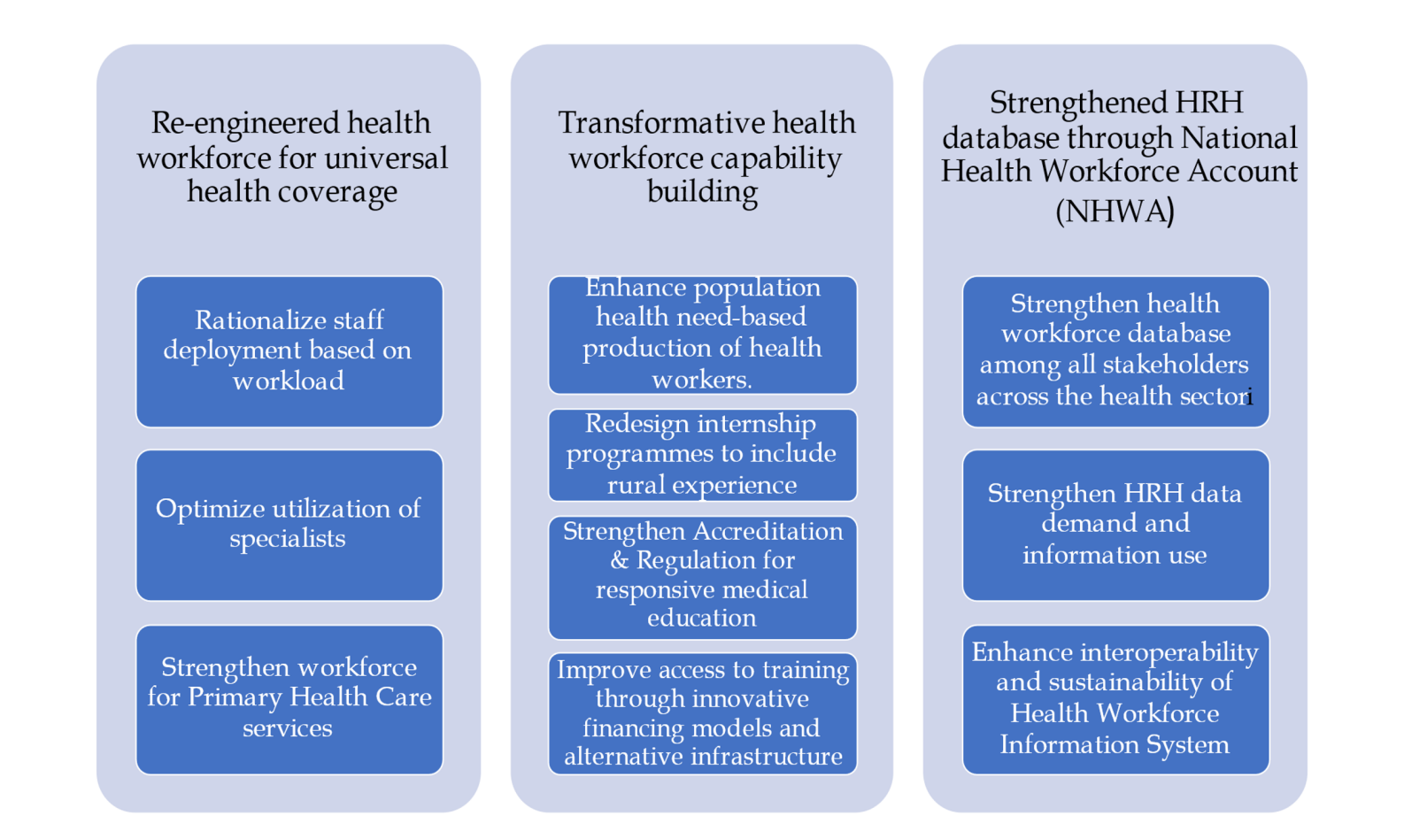

CHAPTER 3

IMPLEMENTATION OF THE NATIONAL HEALTH WORKFORCE ACCOUNTS

3.1 Background

Attainment of the health-related Sustainable Development Goals (SDGs) is dependent on adequate numbers of a health workforce who are appropriately deployed, distributed with right skills mix and competencies.
The performance and benefits of the health system depend largely upon the knowledge, competency and motivation of the health care workers which to a large extent will be influenced by the size, composition, distribution, training, retention, the migration trends, economic development level, sociodemographic, geographical and cultural factors.
The availability of a well-established health workforce information system is of paramount importance to monitor the above-mentioned parameters for the generation of the relevant information for evidence-based planning and management.
Currently, the diverse sources of health workforce data that include the population censuses, labor force and employment surveys, health facility assessments, and administrative databases don’t capture the various dynamics of HRH stocks and flows. Furthermore, they are not designed for the specific purpose of supporting HRH policy and planning.
3.1.1Global calls
Several global forums have adopted resolutions to meet the need for a strong national capacity to regularly collect, collate, analyse and share data to inform policymaking, planning, and management.
WHO member states have been urged to implement policy options towards consolidating a core set of HRH data with annual reporting to the Global Health Observatory, as well as progressive implementation of National Health Workforce Accounts (NHWA), to support national policy and planning. Other interventions include establishment of health workforce registries to track health workforce stock, education, distribution, flows, demand, capacity and remuneration
3.1.2 Implementation Process
The Kenya Health Human Resources Advisory Council (KHHRAC) has been spearheading the implementation of the NHWA in conjunction with a Multi-agency Stakeholders Forum that comprises of the counties and the national levels of the government, the National Referral and Teaching hospitals, other Ministries, State departments, Regulatory bodies, the Faith Based Consortium and the Private Sector and the Educational Institutions. In the Health Act 2017 one of the mandates of the KHHRAC is to review and establish a Master registry of all the health workforce in Kenya.

The National Health Workforce Account
    - What is the National Health Workforce Account?
The National Health Workforce Accounts (NHWA) has been enabling the country (at both levels of government) to progressively improve the availability, quality, and use of data on our health workforce towards the achievement of universal health coverage and other population health goals. It has provided a better understanding of key health workforce characteristics, including its size, skills mix and distribution as well as age and gender.

The main benefits that the implementation of NHWA has enabled the health sector to access are:
- A better understanding of the HWF generating an insight into the needs and possibilities for strengthening the health workforce.
- High-quality HWF information for evidence-based policy strategies, decision making and
- the transformation and scale-up of HWF education and
- training.
- Increased intersectoral policy dialogue among the Ministries of Education, Health and Finance.

- Improved measurement and monitoring of HWF trends, systematic research on health system developments and resilience planning.
3.2 Status of NHWA Implementation Process

3.2.1 Introductory 4-day training

During the first introductory 4-day meeting in September 2019 capacity building for the acceleration of the implementation and institutionalisation of the NHWA was conducted. Consensus was built and established on matters touching on
- Human resource for health (HRH) issues and the HRH information system’s challenges.
- Establishment of structures for shared responsibility in the existing ones in a collaborative manner with the multi-agency stakeholders
- The collected HRH data entry, validation and analysis onto the NHWA data platform
- Implementation and institutionalisation roadmaps for Kenya
- Adoption of local best practices based on the implementation of the regulatory Human Resources Information Systems (rHRIS) for the generation of reliable HRH information
- Conducting work on other beneficial linkages of the NHWA such as the Health Labour Market Analysis (HLMA) .

The participants for this meeting were drawn from the various departments of the MoH, the KHHRAC, KHPOA, the Regulatory bodies, representatives from the Council of Governors- High level County representative. It was facilitated by HRH experts from WHO Geneva Office, AFRO Regional Office and the Country Office as well as the National Council of Kenya (NCK)

3.2.2 Implementation

Conceptualisation activities created a strong foundation for NHWA that established the operational ecosystem that set priority policy directions, roadmap development and the establishment of a governance structure.

The participants were introduced to the eight steps for the implementation of the NHWA that the Kenya team has been adhering to:

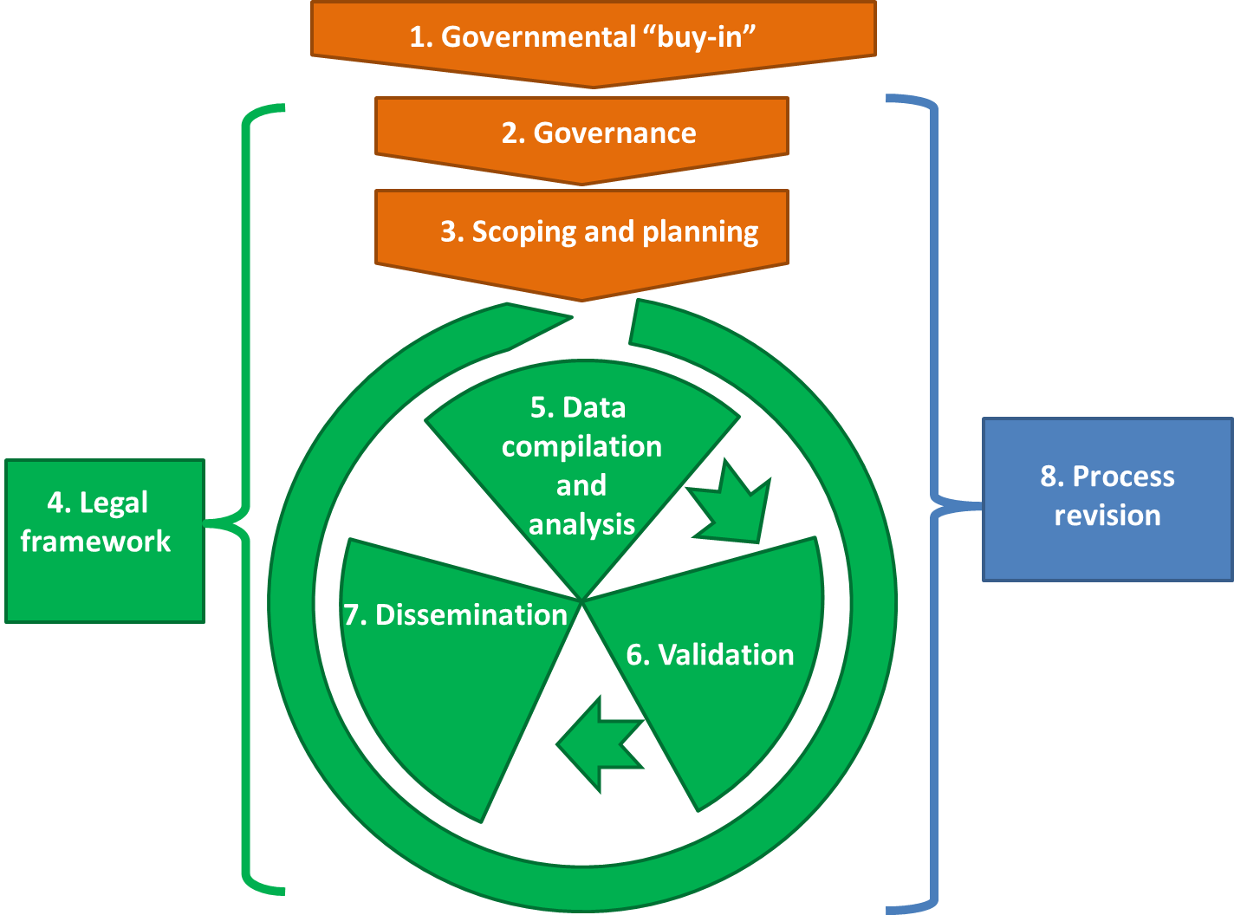

3.2.3 Government buy-in
The road map guided for a consultative forum to sensitise the senior MoH management on the NHWA for the adoption and endorsement of the implementation strategy. Government buy-in with political commitment has supported a successful implementation of the NHWA.

3.2.4 Governance:
- The NHWA Focal person was nominated first by the Principal Secretary, Ministry of Health (MOH).

- A Multisectoral Technical Working Group (TWG) was established with members drawn from all the mapped stakeholders regional County HRH representatives. The Terms of Reference for the TWG were developed and adopted.
- A NHWA Secretariat was set up comprised of a smaller group from core sectors.

Mapping of the stakeholders was prioritised to ensure sustainable processes for the identification, collection, monitoring, use and report on harmonized HRH data in a progressive way. It was informed by the HLM Framework where priority was given to

the sectors playing key roles in the framework and in the life cycle approach of the health worker.

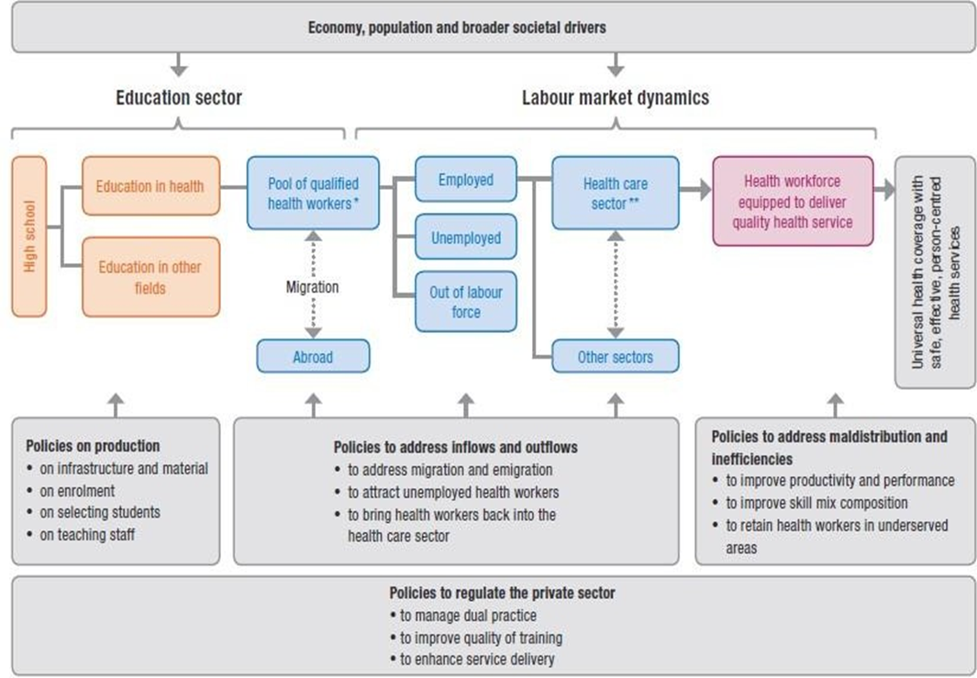
Health Labour Market Framework

Stakeholder Mapping

Health Workforce education

Registration and Licensure

Deployment

Exit

Education Sector

Eduaction policy makers
Training Institutions
Technical and Vocational Educational Institutions
Commission of University Education

Ministry of Health

Director of Human resource Management and Development
Policy and Planning
Human Resources for Health Division
Research
Adminstration
ICT
Regulatory bodies

Other Line Sectors

Private Sector (Kenya Health Federation)
Faith Based Consortium
Labour
Immigration
Public Service Ministry
Teaching and Referral Hospitals
County Public Service Board
Council of Governors
Defence

3.2.7 Scoping and Analysis

Members of the technical working group with HRH expertise conducted a scoping analysis of the current situation of HRH data in the country to provide the following:
- guidance on the selection of data sources;
- to identify data gaps and
- organize multiple sources to fill these gaps; and
- to draft summary reports on the data analysed for validation by the multistakeholder working group.

The relevant members of the TWG included policy-makers and programme managers involved in HRH policy and strategy in the Ministry of Health, Education, Labour and finance; public service commissions, Kenya National Bureau of Statistics, Academia, Health Workers organisations and Health Professional Councils.

The objective of the analysis was to produce evidence on the state HRH in the country as the foundation to the NHWA to guide in the development of a national and global dissemination plan

Prioritisation of the NHWA indicators in the 10 modules was done based on the availability, accuracy, completeness, and quality of data from all the databases in the Country within the government, the regulatory bodies and in the private sectors.

During the scoping analysis, data gaps were identified, and key stakeholders were mandated with the specific efforts and responsibility of gathering the specific data in the various HRH data sources for utilisation during the next steps.

3.2.8 Legal Framework
The need for a legal framework emanates from the recognition that there are diversified sources of the health workforce data with differing levels of confidentiality. Some of the key sources include –
- Ministry of Health (Number of publicly employed, HR by cadre and level of care);
- Ministry of Education (Training institutions, Admissions, graduates, trainers);
- Professional organisations (Number of registered health workers by age, gender);
- Private sector - FBO, PFP (Number of health workers working in private sector);
- Other related sectors (Number of health workers working in these sectors);
- Ministry of Finance (Average annual earning of health workers).

The objectives of the legal framework development are to:
- Assess national legal environment for governance of the multistakeholder working group, data protection rules and regulations
- Ensure requirements are shared, and standard operating procedures (SOP) are adopted by the multi-stakeholder working group
- Obtain authorization for data extraction, exchange and dissemination
The framework is guided by the Data Protection Act No.24 of 2019 that imposes stringent conditions for processing sensitive personal data which is distinguished from personal data. The
Act operates on the principles of lawfulness; transparency; limitation; integrity, confidentiality and availability; data minimization; accuracy; storage limitation; fairness.

CHAPTER 4

DATA COMPILATION AND ANALYSIS

Stock of Health Workers

4.1.0 Background

Health workforce (HWs) component is the cornerstone of health system performance and drives access to, demand for, and quality of health services. The ability of any country to achieve its health priorities depends largely on the health workforce skill mix, quality, deployment, motivation, and responsive leadership and management systems.

As stated earlier, the availability of reliable and accurate health workforce data has been a major challenge since currently we only have the not easily accessible fragmented HRH data sources from the different and diverse sectors. The HRH data sources include Ministries (Health, Education, Labour, Foreign Affairs, Defence, Public Service), Council of Governors and County governments, Departments (Immigration, Training Institutions, Private Sector, FBO, NGO, Professional Councils as well as outside of health facilities.
Significantly, the availability of the private sector and community health workers (CHW) workforce data has been a challenge due to inadequate engagement of the sector to facilitate the access of the relevant information. However, after the development and the adoption of the legal framework, the Data Sharing Agreement all the stakeholders in the Multi-Agency Stakeholders Forum committed to provide the relevant information

4.1.1 Active health workforce stock

Introduction

Health service delivery is at the County level and therefore the majority of health workforce which is in the public sector are mainly found in the counties. During data collection for the NHWA it became evident the health workforce data had to digitized. On the basis of this, the first agenda became the capacity building of the county and national governments human resources managers on the implementation of the integrated Human Resources Information System (iHRIS). It had been implemented in some counties under the HIV program and since it had been a success, it was adopted with some modifications as a reliable source of the health workforce data. The County Managers were also trained on basic data analytics.

In order to ease of the data collection process in the counties, the NHWA Secretariat developed a Data Collection tool with different indicators as required in an Excel sheet. The tool enabled the HRMs to be able to provide accurate data as the tool had a provision to detect errors.

Stock in the Public Sector

The total number of health workers (HWs) in the public sector has increased from an estimated 67,740 in 2018 to 87,236 in 2022 of which 46,408 are males and 40,828 are female translating to 46.8 % and 53.8 % respectively. They are spread across the county health facilities, national health facilities (Mathari and Spinal Injury and Referral Hospitals), headquarters offices, Kenyatta National Hospital (KNH), Kenyatta University Teaching and Referral Hospital (KUTRH) and the Moi Teaching & Referral hospital and at the Port health centres. There are 86,450 community health volunteers (CHVs) in the country to provide services at Level 1.

In the implementation of the NHWA, the data of the health workforce from the other sectors was not yet available because it is not regularly collected, but after the development of the Data Sharing Agreement, it has been agreed that the other sectors will be providing their health workforce data for compilation.

The stakeholders from other sectors in NHWA Secretariat with access to administrative data provided the approximate total number of health workforce in the private sector as 108,802. The total number of the health workforce in the public sector is 87,236 out of which 9,519 are support professionals and non-professionals which leaves 78,172 health professionals. As a result, there are approximately 186,974 health professionals which shall progressively become more accurate as the other sectors in the Multiagency stakeholders Forum provide their accurate health workforce data.

As shown in table 1, Kenya has a total of 189 932 health workers across 13 major health occupations in 2020 across both public and private sectors. Of this stock, about 13 000 are doctors (including 7884 medical officers and 4908 specialists), 110 000 are nurses, 25 000 clinical officers, 1344 dentists and 987 dental technologists. Others included 1337 pharmacists, 6240 pharmaceutical technologists and 1757 physiotherapists, among others.

Table No.1: Total

number the regulated cadres active health workers in the public sector against total public health professionals and against registered

CADRE | Public | % of Total in public sector | Registered | % of all registered in public
Medical Officers | 3,234 | 4.6% | 12,856 | 23%
Medical Specialists | 1,980 | 2.8% | 2,857 | 69%
Clinical Officers | 7,361 | 10.4% | 28,000 | 26%
Nurses | 33,854 | 48% | 57,446 | 59%
Dentists | 291 | 0.4% | 1,351 | 21%
Pharmacists | 1,469 | 2.1% | 4,500 | 32%
Pharmaceutical Technologists | 1,772 | 2.5% | 12,063 | 14%
Lab Technologists | 5,109 | 7.2% | 14,870 | 34%
Radiographers | 619 | 0.8% | 2,000 | 31%
Nutritionists | 1,858 | 2.6% | 12,500 | 14%
Physiotherapists | 671 | 0.9% | 1,986 | 34%
Occupational therapists | 547 | 0.8% | 900 | 61%
HRIO | 1,797 | 2.5% | 3,000 | 60%
Public Health Officers | 4,882 | 6.9% | 5,050 | 90%
Medical Engineers Technologist | 650 | 0.9% | 1,200 | 54%

Figure 2: Numbers of some of the health professionals in the public sector.

4.1.1 Registered and licensed Health Workforce Stock

The current total number of licensed Medical Doctors is 12,856 out of which 7,665 are male and 4,775 are female. Of these 3,234 Medical officers (1,880 male and 1,354 female) are in active service working in the public sector. However, the number of the licensed officers is 9,135 out of the registered 12,856 which could be attributed to unemployment, retention issues or failure to adhering to the annual renewal of practicing license. In Kenya, the following foreign doctors are licensed,1,112 Medical Officers 94 Medical Specialists, 8 Medical Sub specialists, 103 general dental practitioners and 104 dental specialists. The registered medical doctors’ specialists are 2,857 (Male 1,185: female 972). In the public sector, there are 1980 specialists (1192 male and 788 are female) working in the counties and in the Teaching and Referral hospitals. Kenya has 465 foreign licensed Medical Specialists.
Table 1: Registered Local Health worker distribution by age group
Health Worker Cadre
 | M | F | < 25 | 25-34 | 35-44 | 45-54 | 55-64 | >65 | TOTAL
Medical General Practitioners | 5780 | 3803 | 6 | 4363 | 2795 | 735 | 886 | 798 | 9583
Medical Specialists | 1885 | 972 | 0 | 42 | 1107 | 698 | 486 | 524 | 2857
Medical Sub Specialists | 315 | 101 | 0 | 0 | 99 | 156 | 90 | 71 | 416
Dental General Practitioners | 627 | 563 | 0 | 407 | 343 | 118 | 174 | 148 | 1190
Dental Specialists | 101 | 60 | 0 | 1 | 49 | 49 | 33 | 29 | 161
Community Oral Health Officers | 129 | 109 | 6 | 83 | 50 | 56 | 42 | 1 | 238
Source: KMPDC

Foreign trained Doctors
Foreign trained doctors whose qualifications are equivalent to the in-country MBChB and BDS are required to sit Council exams in order to determine their eligibility for either registration or internship training. Recommendations have been expressed that even the Eat African Partner States should also undergo the mandatory pre-internship examination to determine their competence and suitability. Counties have complained that they have received persons with questionable qualifications in as much the
EAC Boards/Councils Reciprocal Recognition agreement is in existence.
Foreign Doctors
Foreign doctors currently acquire temporary registration certificates after which they apply for a temporary license that is valid for one year under the same regulations and code of conduct that guide the practice of medicine and dentistry in Kenya.

Table 5: Number of Foreign Doctors and Nurses by gender and Age with Valid Permits

The number of the foreign doctors and nurses by gender and age were also collected from the State Department of the Immigration as they received the work permits and these numbers are expected to tally with those registered in the regulatory bodies.

 | Profession |  | Gender |  | Age Group
Nationality | Doctors | Nurses | F | M | 25-34 | 35-44 | 45-54 | 55-64 | 65-74 | 75-78 | Grand Total
Indian | 109 | 8 | 23 | 94 | 23 | 57 | 25 | 12 |  |  | 117
Cuban | 76 |  | 32 | 44 | 16 | 18 | 31 | 10 | 1 |  | 76
Ugandan | 62 | 1 | 21 | 42 | 38 | 14 | 7 | 2 | 2 |  | 63
Burundian | 30 |  | 3 | 27 | 7 | 19 | 3 |  | 1 |  | 30
American | 27 | 2 | 11 | 18 | 6 | 10 | 5 | 3 | 5 |  | 29
British | 17 |  | 5 | 12 | 1 | 3 | 6 | 6 |  | 1 | 17
Egyptian | 15 |  | 2 | 13 | 1 | 7 | 5 | 2 |  |  | 15
Tanzanian | 8 | 5 | 9 | 4 | 3 | 4 | 3 | 2 |  | 1 | 13
Congolese | 11 |  | 2 | 9 | 2 | 6 | 2 | 1 |  |  | 11
Rwandese | 6 | 3 | 4 | 5 | 3 | 2 | 1 | 3 |  |  | 9
Congolese (Kinshasa) | 8 |  |  | 8 | 1 | 6 | 1 |  |  |  | 8
Chinese | 7 |  | 1 | 6 |  | 2 | 3 | 2 |  |  | 7
South Sudanese | 6 | 1 | 2 | 5 | 1 | 5 | 1 |  |  |  | 7
German | 6 |  | 2 | 4 |  | 3 | 2 |  | 1 |  | 6
Somali | 6 |  | 3 | 3 | 3 | 3 |  |  |  |  | 6
Canadian | 5 |  | 1 | 4 | 1 | 1 | 1 | 1 | 1 |  | 5
Dutch | 5 |  | 2 | 3 | 1 | 1 | 2 |  | 1 |  | 5
Pakistani | 5 |  |  | 5 |  | 3 | 2 |  |  |  | 5
Others | 40 | 3 | 22 | 21 | 11 | 16 | 9 | 4 | 3 | 0 | 43
Grand Total | 449 | 23 | 145 | 327 | 118 | 180 | 109 | 48 | 15 | 2 | 472

Table 3 shows the number of the different cadres of the nursing professionals have ever been registered over the years from 2017 to 2021

Table 3: Total Number of Nurses EVER Registered
Professional by Cadre | 2017 | 2018 | 2019 | 2020 | 2021
Graduate Nurse | 4,819 | 5,961 | 7,242 | 7,959 | 9,112
Registered Nurse | 51,420 | 57,564 | 58,247 | 63,580 | 76,878
Enrolled Nurse | 23,068 | 23,783 | 28,822 | 38,120 | 38,776
TOTAL | 79,307 | 87,308 | 94,311 | 109,659 | 124,766

Currently there are 57,446 nurses who are registered and active in service, 15,546 are male and 41, 747 are female. Of this number 57,390 are Kenyan nationals while 56 are foreign born. 55,938 are domestically trained while 1508 are foreign trained., 33,854 nursing officers are working in the public sector in the counties, national referral facilities in addition to the National Teaching and Referral hospitals.

Table 3: Registered Nurses of the current active workforce

CADRE | MALE | FEMALE | TOTAL
Nurses | 15,556 | 41,747 | 57,446

Registered Clinical Officers

The total number of Clinical officers are 28,000 of whom 7,361 are working in the public sector. The clinical officers are usually the first point contact with a clinician by the patient especially in some level 2 and Level 3. They therefore play a very key role in the management of patients in the entry of the patient into the Kenya health system. The entry level is a diploma in clinical and surgery.

A number of them who have done post graduate courses that also contribute immensely in the delivery of quality health services. Most of the hospital theatres are run by registered Clinical Officer Anaesthetists, the TB/L Clinics are run by RCO specialized in TB and Skin, ENT Clinics are managed by RCO ENT specialists as well as the eye clinics.

Pharmacists

The registered Pharmacists are 4500 out of which 1469 are working in the public sector and there are 12,063 registered pharmaceutical technologists of whom 1772 are in in the public sector. The normal area of operation is usually from level 3 up to the national referral hospitals. It is important to note that there are a few counties especially the urban ones with facility pharmacies that are run by pharmaceutical technologists.

Rehabilitative services
Rehabilitation involves building up the body's strength, re-learning necessary skills, and adjusting to changes in function as a result of illness or injury. The three main types of rehabilitation therapy are physical, occupational and speech. Each form of rehabilitation serves has a unique purpose in achieving the intended status of well-being in the continuum of care towards full recovery, they all share in reaching the ultimate goal of helping the patient return to a healthy and active lifestyle and therefore they are complimentary for the total healing of the patient. In as much as they play a very crucial role in the wellness of the population whether healthy or unhealthy, the popularity of these cadres is very low compared to the diseases burden. Advocacy of the role they play in the health system needs to be highlighted especially among the students as well as the training institutions.

There are 671 Physiotherapists, 457 Occupational therapists and 392 Orthopaedic trauma technologists in the public sector. Speech therapists were not reported on and it appeared that there are inadequate in numbers even in the training institutions.

4.1.2 Geographical distribution of public health workforce:

The Kenya Health Policy (KHP) 2014–2030 focuses on ensuring equity, people centeredness, participatory, efficient, multi-sectoral approach with social accountability in the delivery of health services. Adequate and equitable allocation of health resources by the government and employment of well-trained health professionals should translate to every citizen irrespective of their place of residence enjoying similar level and quality of healthcare. The assumption is based on the fact that most health professionals have undergone similar training in the same institutions and hence their knowledge and technical know-how is the same.

However, the health workforce is unevenly distributed around the country, with greater numbers in Level 4 and 5 hospitals in the urban and non-arid areas with some regions persistently underserved even after recruitment of more health workers.

Geographically remote counties (Turkana, Marsabit, Wajir) have the lowest density of health workers relative to population size beside a county such as the less densely populated Isiolo county which has the highest health worker to population ratio (this could also be contributed to the increased recruitment that may have occurred at the onset of the pilot of UHC). It would be important to note that there are counties that are sparsely populated and the likelihood of an apparent higher density of health workers is high when that is not the case because the majority of these counties the population are pastoralists with health facilities far apart.

Figure 3: Geographic distribution of the some of the health professionals by County
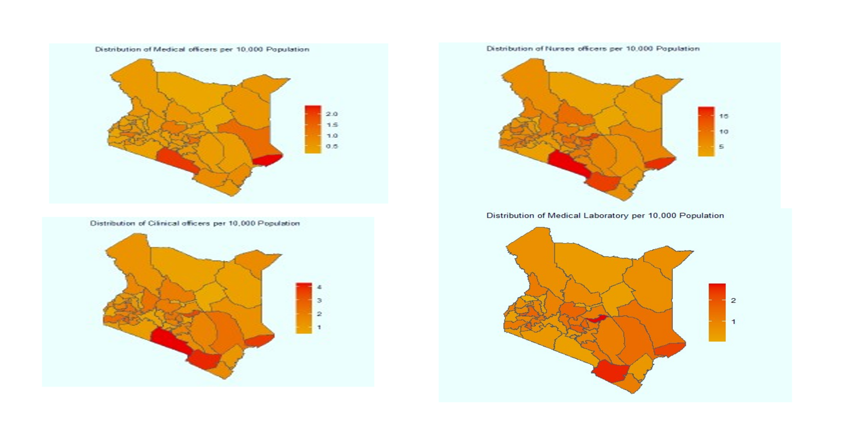

4.1.4 Distribution by levels of care

Universal Health Coverage

Kenya adopted Universal Health Coverage (UHC) in pursuant to the human right to health, as urged to member states during to the 58th World Health Assembly of 2005 (WHO, 2005) with the aim of providing universally accessible health care to all members of the population based on the principles of equity and solidarity. The target is that all people have access to the full range of quality health services they need, when and where they need them, without financial hardship covering the full continuum of essential health services, from health promotion to prevention, treatment, rehabilitation, and palliative care across the life course.

The delivery of these services requires a health workforce with optimal skills mix at all levels of the health system, who are equitably distributed, adequately supported with access to quality assured products, and enjoying decent work.

The cornerstone of the implementation and success of the UHC is strengthening the Primary Health Care (PHC) systems that are in levels 1, 2 and 3 of the Kenya Health System. In the public health sector, 36.5% of the health workforce are in the ambulatory (primary health care) facilities) and are backed up by the Level 1 Community Health Volunteers who total up to 86,490

Figure 8: Distribution of the health workforce in the Kenya Health system.

4.2.3 Distribution of Health workforce by level of care
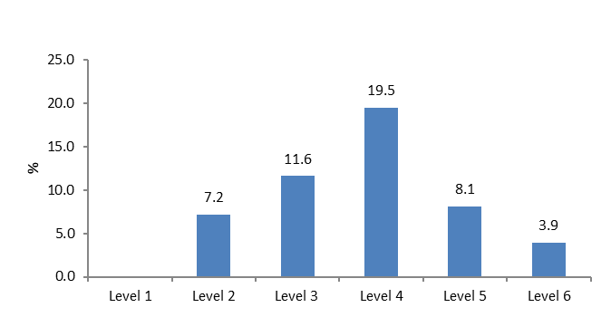

Of great importance to note is that these services require the appropriate skill-mix of the appropriately qualified health professionals to be able to deliver quality services to the patients. Skill-mix has been conceptualized in three ways to mean:
- The range of competencies possessed by an individual healthcare worker;
- The ratio of senior to junior staff within a particular discipline; and
- The mix of different types of staff in a team/healthcare setting.
In order to meet the need of addressing the increasing complexity of their health care problems and the multimorbidity of the patients especially the senior citizens, skill-mix changes have been recommended. These have been classified into four broad role modifications:
- Enhancement (for example, extension of a primary care practice nurse’s role without the need for supervision);
- Substitution (for example, a less expensive prescribing pharmacist expanding their role into the medical domain to substitute partially for a GP);
- Delegation (for example, a GP transferring tasks to a physician associate under supervision);
- Innovation (for example, a physiotherapist leading musculoskeletal clinics that provide a new/enhanced service in primary care).
However, there has been a challenge in the clarification of the function of skill-mix changes and definition of the scope of newly introduced idea since this has been noted to be abused in that complete replacement of the rightful cadre has taken place especially due to the cost implications. This is especially so since the cost of hiring the substitution is lower but professionally not of the calibre of the rightfully qualified professional. This has contributed to inappropriate use of the workers, increased workload, higher costs, lower staff morale/productivity, reduced continuity of care for patients, and inter-professional tensions.

Failure of the appropriate skill mix results in services that are either compromised, delayed or not provided at all which will necessitate unnecessary referral of the patient. In Figure 5, the skill mix in the public sector was computed.

Figure 5: Skill mix in the public sector.
In addition to the insufficient and inappropriate skill mix, the counties outcried the insufficient infrastructure requirements which force some of the health professions especially the medical specialists not to be able to provide services despite their availability.

4.3.1 Gender Distribution

The gender distribution of health workers in Kenya shows that overall, 53% of the health professionals are female, one of the contributing factors being that the majority of the health workforce are nurses of whom the largest proportion are female. It is important to note that among the specialists, the male is dominant. However, it is interesting to note that in as much as the nurses are the majority, the other health professionals are dominated by males.

Figure 2: Total number of Health Workers by gender

4.3.2 Specialist Distribution by gender
Majority of medical specialists are males at 60.2% with a uniqueness in Paediatrics where the majority are female.

4.4.1 Distribution by Age of the Health workforce

67% of the health workforce ranges from is 25-54 years with the majority within the age bracket of 35-44 years. It is of great importance to note that there is need to start planning for the training and preparing replacement of the approximately 30% of the workers who are tending towards retirement considering that the period of training and internship needs to be factored.
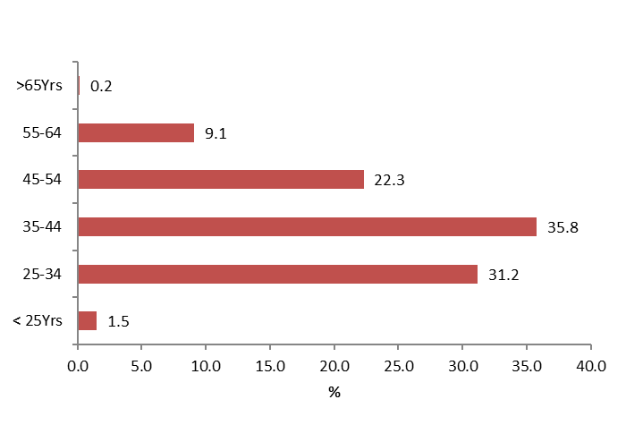
Figure 7: Distribution by Age of the Health workforce

Table 6: Specialist distribution by age group

The age distribution of the specialists shows that over half (55.5%) of them are aged between 35-44 years.

2.1.5: Health workforce density

The density of doctors, nurses and clinical officers per 10 000 in Kenya in 2021 was 20.9. Nevertheless, when all occupational groups are considered, the density was 33.2 health professionals and associates per 10 000 Kenyans which translates to 68% of the SDG threshold of 44.5. In the counties Tharaka Nithi had the highest density of doctors, nurses and clinical officers per 10 000 followed by Taita Taveta which is attributed to the number of the health workers in comparison to the county populations.
Figure 7: Density of some Health professionals in the Country.

4.1. 6 Distribution of Health Workers by Sector of employment

Currently, the only reliable data that is available on the deployment of the health workforce is the public sector data. The main reason for this is that these are employees of the government and the data is easily accessible from the existing systems although as earlier indicated the data sources are diverse and are not hosted in the same location and secondly the data is not intended for planning or decision making.

4.1.6.1 Health Professionals in the Private Sector

Health Professionals in Private Sector | 2017 | 2018 | 2019 | 2020 | 2021
Medical and Dental practice HWs | 94,495 | 99,925 | 106,096 | 94,655 | 97,655
Facilities without accommodation | 7,746 | 8,018 | 8,501 | 8,909 | 8,956
 | 102,241 | 107,943 | 114,597 | 103,564 | 106,611
Source: Administrative
It is important to note that the administrative sources of these figures are reliable and have incorporated data from a whole range of health facilities, from, large medical clinics to the largest private hospitals from across the whole Country. These figures are representative of the health workforce status in the other sectors as we are awaiting the exact figures from the health facilities from these sectors as agreed in the Data Sharing Agreement. These figures in addition to the data from the Public Sector come up with the figure of 189,564.

There has been a steady growth of nurses registered in the past five years as shown in the graph below.
.

Chapter 5:
HEALTH LABOUR MARKET FLOWS
5.1.1 Introduction
Over the last decade, Kenya has attempted to make impressive efforts to strengthen its healthcare workforce with a provision of widening the pipeline of health training and education, as well as attempting to set up mechanisms of ridding the system of “ghost workers.”
However, the country continues to be perceived to face serious unmet healthcare human resources needs whilst the situations are due occurrences on the ground that when measured against global benchmarks give an obscure nuanced information about the supply of qualified health care workers e.g., the migration of nurses from rural locations due to the poor working conditions to urban areas
The apparent high number of unemployed health care workers can be attributed to a substantial percentage of all graduates not practicing medicine since other opportunities in other fields seem more lucrative. Furthermore, female doctors may not be mobile after marrying and starting a family. It is unfortunate that the apparent shortage leads to
the health training institutions graduating large numbers of health workers that is not informed by health labour market supply and demand dynamics..

5.2 Employment Characteristics and Working Conditions
5.2.1 Standard working hours for both Public and Private sectors
The Labour Act confers power on employers to regulate employees’ working hours in line with their contract of service but does not expressly state the maximum working hours of an employee.
In Kenya, the daily work limit is 8 hours per day translating to 40 hours per week. However, health service is provided 24 hours a day at level 6, 5, 4, and 3 hence the facility management have regulated the working hours in shifts to cover the rest of the hours.
SN | Occupation | Standard Working Hours in a week (Public and Private Sectors)
1 | Medical Doctors | 40
2 | General Medical Practitioners | 40
3 | Specialist Medical Practitioners | 40
4 | Nursing Professionals | 40
5 | Midwifery Professionals | 40
5 | Dentists | 40
6 | Pharmacists | 40

    - Part-time contract/ Dual practice Regulation
Dual practice has been a major challenge in the public sector since the employer ends up not receiving quality for money, the health professionals divide their working time between their private practice and the public sector. In many instances, the public sector which is where the majority of the population seeks for health care suffers. There is an urgent need to address this issue Since 2014, the regulatory body stopped license for dual practice and adopted an overall general license for general practitioners and a specialist license for specialists with the provision of private practice which is being abused. Inadequate infrastructure provides a loophole for abuse.

In the private sector, part-time contracts exist and various employers regulate their working hours as per the Employment Act, 2007.

5.2.3 Regulation on working hours and conditions
Various sectors regulate the working hours and conditions as provisioned in Section 27 of the Employment Act, 2007. Cross-cutting regulations on working hours and conditions exist public sector for all workers, but none specifically for healthcare workers. The private sector and other institutions regulate their working hours and conditions that differ between facilities, institutions, and any other organization. It is recommended that there should be consensus on this and if possible, adopted in the multiagency stakeholder’s forum.

5.2.4 Regulation on minimum wage
National law regulating minimum wage exits in Kenya (The Labour Institutions Act, 2007). A Regulation of Wages (General) Order is normally published from time to time to amend the schedule of basic minimum monthly wages and minimum daily and hourly rates.
Health workers in Public Sector are not eligible to receive a minimum wage because their salaries are determined by the Salaries and Remuneration Commission which is mandated to set and regularly review the remuneration of public officers.
    - Regulation on social protection
Kenya, social protection is implemented in both non-contributory and contributory schemes. The Constitution of Kenya (2010) on the Bill of Rights, Article 43 guarantees all Kenyans their economic, social, and cultural (ESC) rights.
In the public sector, as outlined in the Public Service Commission-Human Resource Manual-2016 Health workers are entitled to
- Annual Leave;
- Maternity Leave;
- Child Adoption Leave;
- Paternity Leave;
- Unpaid Leave;
- Compassionate Leave;
- Leave for Sportsmen/women;
- Sick Leave; and
- Terminal Leave.

5.2.5.1 National Social Security Fund (NSSF)
The National Social Security Fund (NSSF) was established in 1965 through an Act of Parliament Cap 258 of the Laws of Kenya. The NSSF is a State Corporation that was established as a mandatory national scheme whose main objective was to provide basic financial security benefits to Kenyans upon retirement. The Fund was transformed from a Provident Fund to a Pension Scheme to which every Kenyan with an income. It is expected to contribute a percentage of the employee’s gross earnings so as to be guaranteed basic compensation in case of permanent disability, basic assistance to needy dependents in case of death and a monthly life pension upon retirement.

5.3.1 Health worker status in employment
Currently the health sector does not have sufficient data on health workers in self-employed but with further engagement with the Ministry of Labour, Kenya will be able to provide the relevant data.
    - Measures to prevent attacks on health workers
Health workforce is at the risk some attacks/ hazards, the most common health and safety hazards in hospitals include:
- Manual handling. This can include lifting, transporting or supporting patients, machinery and equipment.
- Occupational violence.
- Work-related stress.
- Chemical hazards.
- Infectious diseases and agents.
- Slips, trips and falls.
Occupational health is an area of work in public health to promote and maintain highest degree of physical, mental and social well-being of workers in all occupations. Its objectives are:
- the maintenance and promotion of workers' health and working capacity;
- the improvement of working conditions and the working environment to become conducive to safety and health;
- the development of work organization and working cultures that should reflect essential value systems adopted by the undertaking concerned, and include effective managerial systems, personnel policy, principles for participation, and voluntary quality-related management practices to improve occupational safety and health.
Presently, the Occupational Safety and Health Act, 2007 is the only one that has been providing guidance on how to handle matters regarding any injuries that may be sustained while in line of duty.
5.4.2 Attacks on the healthcare system
Attacks on the health-care system is the primary attack on the:
- Facility
- Health-care provider
- Transport
- Patient.
For health-care providers and patients, both components of physical and psychological attacks refer to intentional use of physical force that harms another person physically, sexually or psychologically.
There is inadequate information on the number of attacks on the health -care system. We hope to be able to consolidate this information through the existing various committees such as gender mainstreaming, Safety and Security, Public Complaints, MHRMAC, and Anti-Corruption.
At the National Level, we have Ombudsman, EACC, and Internal Security
5.5 Health Workforce Spending and Remuneration
The public sector health sector is labor-intensive and is dependent on its workforce to provide quality health care services. The country has made significant progress, including scaling up the recruitment of additional health workers, reviewing health worker salaries and benefits, and strengthening human resource systems, policies and practices. In FY 2020/21, the MOH was allocated Ksh 114 billion—an increase from the Ksh 90 billion and Ksh 93 billion allocated in FY 2018/19 and FY 2019/20, respectively. This sum constituted 6.5 percent of the national government budget—a significant increase from the 5.1 percent allocated in FY 2018/19 and 4.8 percent allocated in FY 2019/20. In absolute terms, the MOH budget increased by 27 percent over the three-year period.
5.5.1 Total expenditure on health workforce

The assumption is that Total Expenditure entails wages and salaries, trainings, grants, scholarships among other expenses incurred in the delivery of health services.

5.5.2 Total official development assistance on health workforce
The total incoming financial support received from official development assistance allocated to the health workforce in the country was not available as this data is available at the county level, private sector, faith-based organizations (FBOs), non-governmental organizations (NGOs) and other institutions is currently not available.
KHHRAC received figures from some of the subnational (county) level – Attached Annex 2
5.5.3 Total expenditure on compensation of health workers

The total expenditure on compensation of health workers in the country is not available as data from the subnational level, private sector, faith-based organizations (FBOs), non-governmental organizations (NGOs) and other institutions was not available.
Total expenditure that has been consolidated for public sector in FY 2021/2022 indicates that the National Government spent Ksh. 47,306,000,000/= on compensation of health workers.
5.5.4 Public expenditure on compensation of health workers
In FY 2021/2022, The National Government spent Ksh. 47,306,000,000/= on compensation of health workers. The county (subnational) data was inadequate to calculate a total expenditure on compensation in public sector.

5.5.5 Entry-level wages and salaries
A Regulation of Wages (General) Order is normally published from time to time to amend the schedule of basic minimum monthly wages and minimum daily and hourly rates for the country.
In the private sector, the entry-level salaries may differ between facilities, institutions, and any other organization.
The entry level salaries for health workers in public sector are set by the Salaries and Remuneration Commission and the latest salary scales are as per the last circular on Salary Review for Civil Servants in the National Government of June 2020, as detailed below: -
 | Entry Level | Job Group | Entry Level Salary (Kes)
1. | Certificate | G | 22,270
2. | Diploma | H | 25,470
3. | Degree | K | 38,270
4. | Degree (Medical Officers, Pharmacists, Dentists) | L | 42,970

5.5.6 Policies on public sector wage ceilings

There are no national policies or standards on public sector wage ceilings. However, the Salaries and Remuneration Commission (Remuneration and Benefits of State and other Public Officers) Regulations, 2022 states that the Commission shall, in setting, reviewing and advising on remuneration and benefits, consider various parameters that will guide the public sector remunerations.

5.5.7 Gender wage gap

The median earnings of men and women is the same in the public sector and therefore the gender wage gap does not exist. However, private sector data was not available and thus the gender wage gap for the entire country was not calculated.

CHAPTER SIX:

EDUCATION AND TRAINING

6.0 Introduction

The development of the Health Workforce in Kenya, is largely dependent on a sound education and training framework. The education and training provide the input component of the Health Labour Market Framework (HLMA) as envisaged by WHO (2017). The framework provides for a reflection on policies on infrastructure and material, enrolment, student selection and teaching staff. This chapter reflects on the Education and training modules of the NHWA indicators (Modules 2, 3 and 4) that review education and training to identify strengths and gaps for possible intervention.

These NHWA indicators support the sustainable expansion and reform of HWF education and training to improve the quality of the health workforce as well as increase the quantity and satisfy the relevance needs of the health workforce, and in so doing strengthen national health systems and improve population health outcomes. Information obtained will help guide and inform efforts to reorient and gear the health workforce towards addressing the social determinants of health, health promotion, disease prevention, primary care, and towards offering people-centred, integrated, community-based services. The HWF includes all types of health, social, and support workers.

6.1 Justification

This chapter explores the capacity and quality, including listing and mapping of health workforce (HWF) education and training institutions, and information on applications, admissions, exit/drop-out and graduation. Indicators are aligned with SDG 4 (Education) targets and indicators supporting intersectoral coordination, for example on gender equality. The chapter further explores the planning and monitoring of policies on student selection and admission, enrollment and teaching staff.

6.1 Overview of regulation, accreditation and financing of health workforce education and training

The responsibility and mandate for delivery of education and training for Kenya's health workforce is complex and often a shared responsibility. Institutions responsible for education and training are located both in the national and county governments, regulators, professional bodies, universities, colleges, TVET institutions, MoH training colleges and faith-based organizations that provide various levels of input.
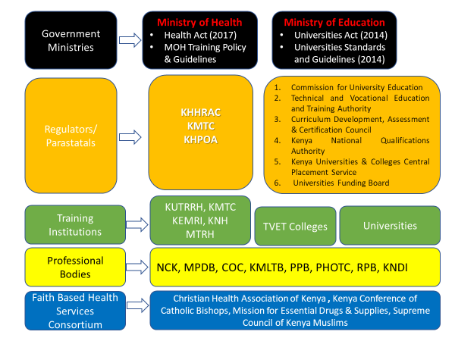
Figure 3.1 Overview of health education and training in Kenya
The health sector organizations which play key roles in the education and training of the health workforce include:

6.1.1 Ministry of Health
The vision of the Ministry of Health is to ensure that we have “A healthy, productive and globally competitive nation”, underpinned in eight (8) policy orientation areas, six (6) strategic objectives under the principles of equity, efficiency, and people centered with a multi sectoral approach.
The Sector has thirteen (13) Semi-Autonomous Government Agencies (SAGAs) namely, Kenyatta National Hospital (KNH), Moi Teaching and Referral Hospital (MTRH), Kenyatta University Teaching Research and Referral Hospital (KUTRRH), Kenya Medical Research Institute (KEMRI), Kenya Medical Supplies Authority (KEMSA), Kenya Medical Training College (KMTC), National Health Insurance Fund (NHIF), National Aids Control Council (NACC), National Cancer Institute of Kenya (NCI-Kenya), Medical Practitioners and Dentist Council (KMPDC), The Mathari National Teaching & Referral Hospital (MNTRH), Nursing Council of Kenya (NCK) and Kenya Nuclear Regulatory Authority (KNRA). The Kenya Health Human Resource Advisory Council (KHHRAC) and the Kenya Health Professions Oversight Authority (KHPOA) are in the final process of being considered as SAGAs.

6.1.1.1 Kenya Health Professions Oversight Authority (KHPOA)
The Kenya Health Professions Oversight Authority is a body corporate established by part VI of the Health Act no. 21 of 2017 to provide an oversight role for the regulatory boards and councils. The mandate of the Authority is to provide oversight in training, registration and licensing of health professionals; coordinate joint health inspections; receive and facilitate resolution of complaints and arbitrate disputes and conflicts; monitor execution of respective mandates and functions of health regulatory bodies.

6.1.1.2 Kenya Medical Training College
The Kenya Medical Training College (KMTC) as a State Corporation under the Ministry of Health is entrusted with the role of training various health medical field disciplines and aligns its strategies to those of the health sector, which in turn draws its focus from Kenya’s Vision 2030. The College has 71 campuses, with its headquarters in Nairobi. It conducts registration of graduates using a database connected with the Kenya National Qualifications Authority which aims at protecting data, ensuring authenticity of certificates and enabling graduates to compete globally.

6.1.1.3 Health NGOs Network
Health NGOs Network (HENNET) was registered in 2007 as an NGO with a goal of coordinating and networking the NGOs in the health sector, with the following List of Members – HENNET. Private hospitals also provide and fund a small amount of training to postgraduate medical students
6.1.1.4 Kenya Faith Based Health Services Consortium (KFBHSC)
Faith based health services in Kenya are coordinated through the Kenya Faith Based Health Services Consortium (KFBHSC) whose membership includes Christian Health Association of Kenya (CHAK), Kenya Conference of Catholic Bishops (KCCB), Mission for Essential Drugs and Supplies (MEDS) and Supreme Council of Kenya Muslims (SUPKEM).

6.1.2 Ministry of Education
The Ministry of Education derives its mandate from the Constitution of Kenya, Chapter Four Articles 43, 53, 54, 55, 56, 57, and 59 which provides for children’s right to free and compulsory basic education, including quality services, and to access education institutions and facilities for persons with disabilities. The State Department for University Education and Research (SDUE&R) has the following core functions:
- University Education Policy;
- University Education Management;
- Management of Continuing Education (excluding TVETS);
- Science, Technology and Innovation policy;
- Public Universities and Constituent Colleges
- Governance of public universities
- Biosafety management
The functions of the State Department are also guided by the Universities Act 2012 Revised (2015, 2016 and 2018), and the Science, Technology and Innovation Act 2013 and the Sessional Paper No. 1 of 2019 on a Policy Framework for Reforming Education and Training for Sustainable Development in Kenya.

6.1.2.1 Semi-Autonomous Government Agencies (SAGAs) in the State Department
In order to effectively undertake its mandate, the State Department also comprises Public Universities, University Constituent Colleges and specialized degree awarding institutions. The State department has eight (8) Semi-Autonomous Government Agencies (SAGAs), which are charged with various responsibilities as presented in table 1.
Table1: SAGAs and their Mandate
S/NO | SAGA | MANDATE
1 | Commission for University Education (CUE) | Established under the Universities Act 2012 to accredit and quality assure university education in both public and private universities.
1. | National Commission for Science, Technology and Innovation (NACOSTI) | Established under the STI Act 2013 to accredit and assure quality in Science, Technology and Innovations (ST&I) and advise the Government on related matters.
2. | Kenya National Innovation Agency (KENIA) | To scout for and nurture innovative ideas from individuals, training institutions, the private sector and similar institutions.
3. | National Research Fund (NRF) | Established under the STI Act 2013 to mobilize and channel resources for research, science, technology and innovation.
4. | Bio safety Appeals Board (BAB) | To make rules and regulation for appeal procedure, hear Appeals from persons aggrieved by decisions made by the National Biosafety Authority (NBA), and communicate decisions to the parties involved and public.
5. | Higher Education Loans Board (HELB) | Source for funds and finance Kenyan students enrolled in recognized institutions of higher learning, both within and outside the country. It handles loans, bursaries and scholarships for needy students in public and private universities. The Board also has the mandate of recovering all mature loans issued since 1974.
6.
7. | Universities Funding Board (UFB) | Established under the Universities Act 2012 to mobilize and manage resources for financing university education
8. | Kenya Universities and Colleges Central Placement Service Board (KUCCPS) | Was established under the Universities Act, 2012 as a body corporate to coordinate placement of Government sponsored students into universities and colleges.
9. | Universities and Constituent Colleges | To provide university education through teaching, research and consultancies

6.1.2.2 TVET sub-sector
The Goal of the sector is to provide relevant and adequate skills and competencies in strategic disciplines by 2020 for spurring industrial and economic development in line with the aspirations of the Kenyan peoples. The specific functions of the TVET are:
  - Promotion of standards for technical education
  - Practical/industrial attachment and internship
  - Facilitation of curriculum development
  - Assurance of quality of curriculum implementation
  - Registration of TVET institutions
  - Coordination of technical and business examinations
  - Assessments of Institutional facilities and capacity for TVET

6.1.2.3 Commission for University Education (CUE)
Established by an Act of Parliament, Universities Act, No. 42 of 2012, CUE, is the national regulator and quality assurance Agency of university education in Kenya. It achieves this through setting standards & guidelines and monitoring compliance. The CUE is the national regulator responsible for accreditation of universities and programmes that offer health related programmes, among other programmes. CUE has published a list of accredited programmes available on the link academic programmes.

6.1.2.4 Technical and Vocational Education and Training Authority (TVETA)
Technical and Vocational Education and Training Authority is a public corporate agency established under the Technical and Vocational Education and Training (TVET) Act No. 29 of 2013 to regulate and coordinate training in the country through licensing, registration and accreditation of programs, institutions and trainers. Section 7 of the Act, 2013 gives the powers and functions of the Authority to regulate and coordinate training; inspect, license and register and accredit training institutions; accredit and inspect programmes and courses; promote access and relevance of training programmes; determine the national technical and vocational training objectives; assure quality and relevance in programmes of training among other functions.

6.1.2.5 Curriculum Development, Assessment and Certification Council (CDACC)
The Curriculum Development, Assessment and Certification Council is mandated to undertake design and development of Curricula for the training institutions’ examination, assessment and competence certification; issue certificates to candidates who satisfy national TVET examination and competence assessment requirements; and investigate and determine cases involving indiscipline by candidates registered with it.

6.1.2.6 Universities Funding Board
The Universities Fund was established under section 53 of the Universities Act, 2012 for financing Universities in Kenya. Apportion funds to universities in accordance with criteria established. Some of the functions of UFV that relate to health workforce education and training include, to:
  - Mobilize and receive funds for purposes of the fund from the Government, donors and from other sources;
  - establish the maximum Differentiated unit Cost for the programmes offered, in consultation with the public universities;
  - Establish the minimum discipline differentiated remuneration for academic staff of universities; and
  - develop a transparent and a fair criterion for allocation of funds, in consultation with the Cabinet Secretary.
The UFB has established a Maximum Differentiated Unit Cost – University Fund as specified in the table, and a section extracted as follows

 |  | Maximum Differentiated Unit Cost in KES
No | Subject Area | Diploma | BTech | Bachelors | Master | Doctorate
1 | Medicine -Pre Clinical | 216000 | 324000 | 360000 | 432000 | 480000
2 | Medicine -Clinical | 432000 | 588000 | 720000 | 864000 | 972000
3 | Dentistry -Pre-Clinical | 216000 | 324000 | 360000 | 432000 | 480000
4 | Dentistry-Clinical | 432000 | 588000 | 720000 | 864000 | 972000
5 | Pharmacy-Pre-Clinical | 216000 | 324000 | 324000 | 384000 | 432000
6 | Pharmacy -Clinical | 336000 | 408000 | 504000 | 600000 | 672000
7 | Health Sciences, Food Science and Technology, Medical Laboratory science and Technology , Nursing, Clinical Medicine (B.Sc) SPorts science, Foods and Nutrition, Medical Psychology, Public Health, Community Health and Development | 216000 | 324000 | 324000 | 384000 | 432000
 | Exercise and Sport Science, Biochemistry, Biotechnology, Biomedical sciences, Applied Microbiology, Applied and Technical Biology | 192000 | 288000 | 288000 | 348000 | 396000
Source: UFB (2022)

6.1.2.6 Kenya National Qualifications Authority (KNQA)

The Kenya National Qualifications Authority was set up in 2015 to help coordinate and harmonize education, training, assessment and quality assurance of all qualifications awarded in the country; with the view to improving quality and international comparability. The Authority has developed and is implementing online applications and processing of Alignment and Validation of national and foreign qualifications. The system allows all applicants to create their own profile, upload documents and make payment using the online portal. This ensures that only Qualifications that meet standards set by the KNQA and have been validated to be Authentic and Genuine are admitted into the Kenya National Qualifications Database.

6.1.2.7 Kenya Universities and Colleges Central Placement Service
The Kenya Universities and Colleges Central Placement Service (KUCCPS) is a State Corporation that provides career guidance and selects students for admission to universities, national polytechnics, technical training institutes and other accredited higher learning institutions for Government of Kenya-sponsored programmes. KUCCPS was established to coordinate the placement of Government-sponsored students to Kenyan universities and colleges; develop and implement career guidance programmes; disseminate information on available programmes; and collect and retain data relating to university and college placement.
KUCCPS has a student portal that guides students for application of programmes under Cluster 13 for Medicine, Health, Veterinary Medicine and Related programmes at the level of Artisan, Certificate, Diploma and Degree level. The specific minimum entry requirement for each of the programmes are also provided and can be found in the following site: https://statics.kuccps.net/uploads/globalFiles/DEGREE%20CLUSTER%20DOCUMENT-2022.pdf
KUCCPS retains data on applications by students for placement to medical related programmes in the university and TVET sectors. Application data facilitate the computation of the ratio of applications for health workforce education and training to training places (NHWA 2-03), and hence establish the demand from the user perspective, for health education and training.

6.1.2.7 Higher Education Loans Board.
The Higher Education Loans Board (HELB) is a statutory body established in July 1995 by an Act of Parliament 'Higher Education Loans Board Act' Cap 213A. Key among the responsibilities of the Board is sourcing funds, establishing, managing and awarding loans, bursaries and scholarships to Kenyans pursuing higher education in recognized institutions.

3.1.2.8 Universities
Universities play a critical role in the production of a health workforce. The placement is undertaken by the KUCCPS, with funding support from UFB and HELB. The training programmes are accredited by CUE, after an initial approval by the relevant professional body.

3.2 Accreditation of health workforce education and training

3.2.1 Accreditation of health workforce education and training institutions
The accreditation of education and training of the Health Workforce Education Sector is under the purview of legally established regulatory bodies. University education is regulated by the Commission for University Education, while the Technical and Vocational Education and Training Authority (TVETA) regulates the TVET sector. Institutions under the Ministry of Health have the Kenya Health Professions Oversight Authority (KHPOA).
Accreditation of health-related university programmes requires initial approval of the programme and facilities by the relevant professional body, before accreditation by CUE. The list of accredited institutions authorized to offer medical related programmes are listed in the respective websites of the three bodies. For Universities Status Of Universities (Universities Authorized to Operate in Kenya), while for TVETA Institutions – TVETA and for KMTC campuses Ministry of Health Campus List | Kenya Medical Training College.
Table 3.1 List of accredited medical related bachelor level programmes in Kenyan Universities
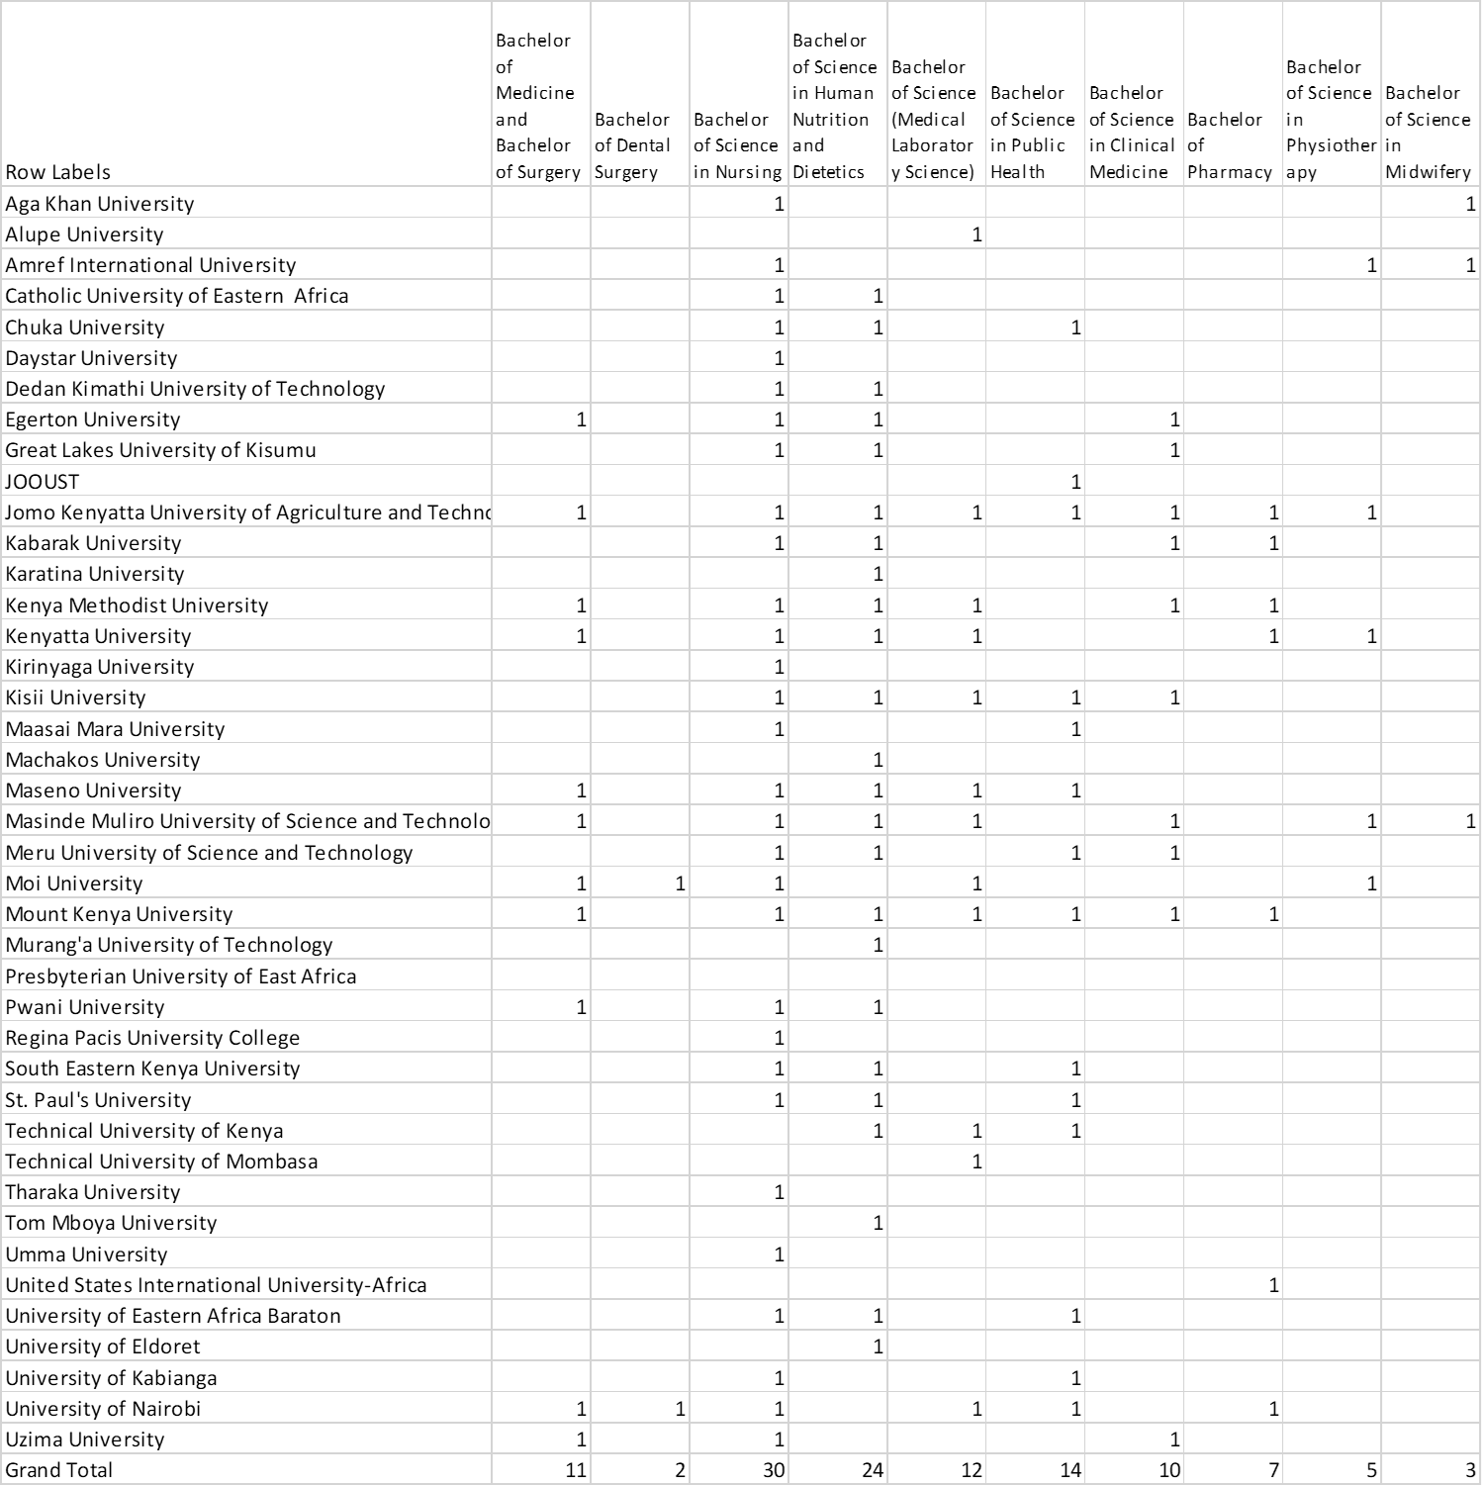
The Kenya Medical Training College (KMTC) expanded the campuses from 64 in 2017/18 to 75 in 2020/21 and this increased student enrollment from 12,605 in 2017/18 to 16,664 in 2020/21. Additional 160 classrooms and 10 libraries were constructed to cater for increased student intake.

Other Semi-Autonomous Government Agencies (SAGAs) that offer training include: Kenyatta National Hospital (KNH), Moi Teaching and Referral Hospital (MTRH), Kenyatta University Teaching Research and Referral Hospital (KUTRRH), Kenya Medical Research Institute (KEMRI), Kenya Medical Training College (KMTC).
Kenya has eleven (11) regulated cadres and the regulatory bodies have the mandate to accredit the training of cadres under them and the training institutions. Among the large ones are:
- Kenya Medical Practitioners and Dentists Council regulates the training, practice and licensing of medicine & dentistry and healthcare institutions that include private & mission hospitals, medical, dental centers & clinics, nursing and maternity homes and standalone funeral homes.
- Nursing Council of Kenya ensures that the nursing and midwifery workforce is well regulated and equitably distributed at each level of care. This is achieved through capacity building and training of nurses, registration and regulation of their conduct for improved performance of the profession.
- Clinical Officers Council mandate is to regulate the training, registration, licensing and practice of Clinical Officers. The council approves institutions other than those established or accredited under the Universities Act, 2012 for the training of clinical officers investigate and determine cases involving indiscipline by candidates registered with it.

6.2.2 Duration of education and training for Kenya

The duration of education and training is dependent on the level of training and type of programme on offer. In order to standardize the duration of training, the Kenya National Qualifications Authority (KNQA) was established to harmonize the qualifications landscape in Kenya and provide for a Kenyan qualification. KNQA was set up in 2015 as set out in the Kenya National Qualifications Framework (KNQF) act no. 22 of 2014 to coordinate and harmonize the various levels of education; and to create a database of all qualifications in the country.

The functions of KNQA include to develop and review inter-relationships and linkages across national qualifications in consultation with stakeholders, relevant institutions and agencies, and to advise and support any person, body or institution which is responsible for the award of national qualifications. Further, KNQA is mandated to establish standards for harmonization and recognition of national and foreign qualifications, among other activities. Besides the function of KNQA, the duration of health workforce education and training is guided by the assigned regulators and related professional bodies in the different sectors.
- Universities
The Universities Standards and Guidelines (2014) under PROG/STD/02 specify that “Each level of academic programme shall be differentiated by specific attributes. Higher levels of academic programmes shall require more complex attributes according to Bloom’s Taxonomy”. Specifically, for Medical and Allied Sciences, a Bachelors’ academic programme is required to carry a minimum of 3960 instructional hours.
- TVET
The list of Approved Occupational Standards and Curricula for medical courses are listed on the TVET website (see link Tvet Curriculum Development, Assessment And Certification Council (TVET CDACC) Approved Curricula And Occupational Standards No
The duration of programmes is specified by the Kenya National Qualifications Authority (KNQA) level descriptors, which classifies them under level 4, 5 and 6 Level Descriptors - Kenya National Qualifications Authority
Level | Minimum Volume of learning
4 | 600 Hours or 60 Credits or a minimum of 6  Months after level 2 OR 30 credits after level 3
5 | 1200 Hours or 120 Credits or a minimum of 1 Year after level 2 OR 60 credits after level 4
6 | 2400 Hours or 240 Credits or a minimum of 2 Years after level 2 OR 120 credits after level 5

- Programmes under the Ministry of Health
The following table is a summary of the duration for courses offered by the Kenya Medical Training College for different levels of training.
Entry Requirements | Kenya Medical Training College
Level of training | Duration of training
Certificate | 2 years with the exception of nursing which takes 2 ½ years
Diploma | 3 years except Community Health Nursing which lasts 3 ½ years
Upgrading | 2 years except Community Health Nursing which lasts 18 Months
Higher Diploma | 1 year
Short Courses | 2 weeks – 3 Months

The master list of accredited health workforce education and training institutions are up to date and available in the public domain.

6.2.3 Applications for education and training
Applications for placement in universities and colleges are coordinated by the Kenya Universities and Colleges Central Placement Service (KUCCPS). Education and training institutions in the Ministry of Health apply online to KMTC. Future efforts will seek to obtain targeted data on the number of applications.

6.2.5 Ratio of students to qualified educators for education and training
For University Education, the Universities Standards and Guidelines under PROG/STD/17, Section 5 provides that the recommended full-time staff: student ratio for Medical and Allied Sciences is 1:7, while for Applied Sciences is 1:10. Mechanisms exist in the university and TVET sector to establish adherence to the provided ratio of students to qualified educators. Additional data on ratio of students to qualified educators will be sourced for the next report

3.3 Education & Training Regulation
This section reviews the available mechanisms to coordinate an intersectoral HWF education and training regulation, by an examination of the quality assurance, and education and training requirements. Accreditation mechanisms and their standards are of key importance, so that national education plans for the health workforce are aligned with the national health plan to ensure that all health workers have the skills that match the needs of the population. An indicator on in-service training looks to align health sector training with other educational sector-wide policies and programmes, including technical and vocational education and training within a framework of lifelong learning. The review seeks to enhance the quality and relevance of HWF education and training, and identify areas of intervention in the regulation or management of education and training.

6.3.1 Standards for the duration and content of education and training
a. Universities
(i) Entry requirements
The Commission for University Education is mandated to set standards for duration and minimum entry requirements. However, specific entry requirements are provided in the accredited curriculum of individual universities.
The University Regulations provide in Section 48(1C) that the admission criteria and credit transfers for academic programmes shall be as provided in the Universities Standards and Guidelines (2014). The standards are available from University Standards & Guidelines
Professional bodies have specific entry requirements such as
- requirements to be admitted to Bachelor of Medicine and Bachelor of Surgery degree programme or its equivalent must satisfy certain indexing requirements Undergraduate Training. These include:
- For Kenya Certificate of Secondary Education holders, minimum university admission requirement is C+ (plus) and in addition, an average of B plain in each the of the following cluster subjects:
  - Biology
  - Chemistry
  - Physics or Mathematics; and
  - English or Kiswahili
- For Kenya Advanced Certificate of Education holders, a minimum of two principal passes in Biology, Chemistry and a subsidiary pass in either Mathematics or Physics.
- For International Baccalaureate (IB), a minimum of grade 5 or above in International Baccalaureate.
- For Diploma holders in Medical Sciences, a minimum “O” level Division II pass or C+ (plus) mean grade and a credit C+ pass in the cluster subjects in K.C.S.E., in addition to a three-year diploma with a minimum of a credit pass from a medical training institution recognized by the Board.
- Proficiency in English language.
- For holders of any degree in Biological Sciences or equivalent qualifications from a recognized university, subject to passing Graduate Record Examination (GRE).
- Other qualifications deemed to be equivalent to those in paragraphs (a)-(d) above from institutions recognized by the different institutions’ Senates

(ii) Duration
Standards for the duration of education and training are specified under the third Schedule of the Universities Standards and Guidelines (2014), which provides 20 standards and related guidelines for academic programmes.
For Medical and Allied Sciences, the standard PROG/STD/06 prescribes a minimum of 3960 instructional hours. One instructional hour is equivalent to:
- one (1) contact hour in a lecture-designed session;
- two (2) contact hours in a tutorial-designed or open-learning-designed session;
- three (3) contact hours in a laboratory-designed or practicum session; and
- five (5) contact hours in a farm or similar practice.
(iii) Content
The content for Human Medicine is standardized under the Credit Accumulation and Transfer System ( see link) Credit Accumulation and Transfer System enters its fifth phase The Commission hosted a one-day workshop on 13th February on draft
Other medical related programmes at degree level are yet to have standardized national curriculum
b) TVET Curriculum Development
Curriculum development for the TVET sector is undertaken by a multiplicity of players. For institutions that are accredited by TVETA, the body legally charged with curriculum development matters is the Curriculum Development, Assessment and Certification Council (CDACC). a body corporate established under the Technical and Vocational Education and Training (TVET) Act, No. 29 of 2013.
The Council is mandated to undertake design and development of Curricula for the training institutions’ examination, assessment and competence certification. This is in line with the provisions of the Sessional Paper No. 2 of 2015 that embraces Competency Based Education and Training (CBET) system. According to the TVET Act No 29 of 2013, the Council is mandated to undertake design and development of curricula for the training institutions’ examination, assessment and competence certification. Further, the Council is mandated to issue certificates to candidates who satisfy national TVET examination and competence assessment requirements
KMTC Curriculum Development
The Kenya Medical Training College (KMTC) was established in 1927 through an Act of Parliament Cap 261 of the Laws of Kenya, and later amended by Act No. 5 of 2019. Section 5 (g) provides a function for KMTC to “determine who may teach and what may be taught and how it may be taught in the College”. The curriculum for KMTC programmes is guided by the KMTC-Curriculum-Policy https://kmtc.ac.ke/wp-content/uploads/2019/06/11.-KMTC-Curriculum-Policy.pdf . The available programmes are listed in the https://kmtc.ac.ke/wp-content/uploads/2020/02/KMTC-Programmes-Courses-Feb-2020.pdf

b. TVET
(i) Entry requirements
The duration of training is provided by the KNQA as per the link
https://www.knqa.go.ke/index.php/level-descriptors/#7ab4deebc3d3a434c
Specifically, the various level descriptors and their entry requirement are as follows:
KNQA Level Descriptors | Level Descriptions | Entry Requirement
6 | National diploma/  Professional diploma | KCSE C- (Minus) or KCE division II, KACE one (1) Principal or an equivalent qualification or Certificate of Experiential Learning or KNQF 5
5 | National certificate | KCSE D (plain), KCE Div. III or equivalent qualifications or Certificate of Experiential Learning or completion of KNQF level 4
4 | Artisan certificate/ National Vocational certificate III/ National skills certificate I | KCSE E, KCE Div. IV, or Certificate of Experiential Learning or completion of KNQA level 2 or 3
3 | National Skills Certificate II (NSC-II)/Government Trade Test II (GTT- II)/National Vocational Certificate II (NVC- II) | KCPE Certificate, KCSE certificate E, KNQA level 1 or 2

(ii) Duration
The duration of programmes are specified by the Kenya National Qualifications Authority (KNQA) level descriptors, which classifies them under level 4, 5 and 6 as captured in 2- 02 above.
Level Descriptors - Kenya National Qualifications Authority

(iii) Content
The content is prescribed by standards provided by the Technical and Vocational Education and Training Curriculum Development, Assessment and Certification Council (TVET CDACC). The Curriculum development process is provided in the link TVET Curriculum Development Assessment and Certification Council , while the policy is provided in the link Competency Based Education and Training Policy Framework | TVET CDACC
c) Ministry of Health Institutions
(i) Entry requirements
The entry requirements for different KMTC courses is standardized as per the link provided Entry Requirements | Kenya Medical Training College , which is modeled on the national standard of entry requirements by KNQA https://www.knqa.go.ke/index.php/level-descriptors/#
The entry requirements for the different KMTC courses are as follows:
S/NO | Level of training | Entry Requirement
1 | Certificate | A minimum aggregate of C- with a relevant combination of other subjects is a requirement.
2 | Diploma | KCSE mean grade of C (or equivalent) with a relevant combination of other subjects such as English, Kiswahili, Biology, Biological Sciences, Mathematics, Chemistry, Physics and Physical Sciences.
3 | Upgrading | Holders of a certificate in relevant fields and at least two years working experience.
4 | Higher Diploma | Holders of basic Diploma in relevant fields and at least a minimum of two years working experience.
5 | Short Courses | Individuals and groups such as corporate bodies, companies and government ministries interested in any course or courses can make a written request for arrangements to be made.

ii) Duration.
For health workforce education and training institutions under the purview of the MoH, the duration of training is a mandate of the relevant professional bodies. For instance the KMPDC lists as one of its functions the mandate to prescribe the minimum educational entry requirements for persons wishing to be trained as medical and dental practitioners (see link Medical Practitioners And Dentists Act). The standard on duration of training is provided in regulations. Similarly, the Nursing Council of Kenya
The set duration has been agreed on and prescribed by the KNQA in the level descriptors https://www.knqa.go.ke/index.php/level-descriptors/#
(iii) Content

6.3.2 Accreditation mechanisms for education and training institutions
Existence of national and/or sub-national mechanisms for accreditation of health workforce education and training institutions and their programmes

(a) Universities
At the national level, medical related university education and training is regulated by the Commission for University Education. The accreditation process is described on the link Commission for University Education - Accreditation. Accreditation in Kenya means public acceptance and confirmation evidenced by the award of a Charter, which a university meets and continues to meet the standards of academic excellence set by the Commission. Universities apply only for programme accreditation using the link Login - CUE
The CUE works in partnership with relevant professional bodies who are required to have given approval for accreditation of programmes in a university. The professional bodies provide regular updates on universities accredited to offer medical related programmes. Some examples are:
(i) List of approved Medical & Dental schools Undergraduate Training
The Kenya Medical Practitioners and Dentists Council undertakes the approval of all medical and dental training institutions in the country. As at December 2022, the following universities had their medical schools approved:
- University of Nairobi
- Moi University
- Kenyatta University
- Egerton University
- Kenya Methodist University
- Maseno University
- Jomo Kenyatta University of Agriculture and Technology
- Mount Kenya University
- Uzima University
- Masinde Muliro University of Science and Technology
- Kisii University
Approved Dental Schools in Kenya
- University of Nairobi
- Moi University
A point to note is that it was highlighted that some of the Universities that are providing the training on medicine do not have the pre-requisite infrastructure as is necessary for the comprehensive training to all the students that have been accepted into the universities. The recommendation of reinforcement of the adherence to the requirements that need to be in place before a University is granted the accreditation to train medical students was stressed on to ensure that the quality of the professionals is up to par.

(ii) TVET
The Technical and Vocational Education and Training Authority (TVETA) is a public corporate agency that regulates and coordinates training in the country through licensing, registration and accreditation of programs, institutions and trainer. Its mandate is to inspect, license and register and accredit training institutions; accredit and inspect programmes and courses; promote access and relevance of training programmes; determine the national technical and vocational training objectives; assure quality and relevance in programmes of training.
(i) The institutions registered are available through this link Institutions – TVETA
(ii) The Approved CBET Curricular (programmes) are available through this link Approved CBET Curricula – TVETA

(iii) MOH Training Institutions
The Kenya Medical Training College coordinates training of different mid-level medical programmes and courses in various KMTC campuses across the country. It's also mandated to start new campuses, initiate new programmes, review and standardize the existing courses.
(i) List of KMTC Campuses is under the following link:
Campus List | Kenya Medical Training College
(ii) List of different programmes and courses is provided in the link :
https://kmtc.ac.ke/list-of-courses/
However, it was cited that the establishment of the KMTCs in the Counties is facing a challenge in that there are incidences where the Campuses have been established by the politicians without consultation with the KMTC and therefore the qualification of the institutions for training is questionable. The recommendation is the reinforcement of the clear procedures in the establishment of new campuses.

6.3.3 Standards for social accountability

Social accountability refers to the obligation of an authorized body to direct its education, research, and service activities towards addressing the priority health concerns of the community, region, and/or nation it has a mandate to serve. (Boelen and Heck 1995). |The indicator seeks to measure if social accountability is included or reflected within national standards, and if there is involvement of civil society, other social stakeholders and communities in accreditation mechanisms.
In Kenya, there exists national standards and requirements for social accountability in accreditation mechanisms. The Constitution of Kenya has provisions for stakeholders’ involvement. This is further enshrined in other legal and policy documents that specifically guide the functions of government and state corporation’s accreditation mechanisms. The State Corporations Advisory Council (SCAC) provides a platform for addressing shareholder rights and obligations and ensuring more effective engagement with stakeholders as outlined in the Mwongozo (The Code of Governance for State Corporations) document available from: https://wasreb.go.ke/downloads/MWONGOZOCODEOFGOVERNANCE.pdf

6.3.4 Standards for social accountability effectively implemented

This section seeks to establish the effectiveness of implementation of national standards for social accountability in accreditation mechanisms. Specifically, the dimension reviews whether the national mechanisms for accreditation of health workforce education and training institutions and their programmes require compulsory reporting on implementation of national standards on social accountability. The compulsory reporting of social accountability is included in the Mwongozo principle and other regulatory documents. For instance, the CUE regulation of programmes in university education has a compulsory provision for stakeholder involvement in the initial process of programme accreditation as well as period programme review. Specifically, the Standard INST/STD/016/4 4) requires a university at all times to “prioritize the academic interests of students and other stakeholders in carrying out its operations”. In addition, PROG/STD/07 provides that the “rationale of the programme shall be convincing and evidence-based” and informed by “stakeholders’ requirements”.
In the TVET Sector,
Communities of practice, represented by professional bodies, have a say in health workforce education and training institutions as they are required to give the initial approval before a programme commences. There is a compulsory requirement for needs assessment before any programme is accredited. This is also evident in the non-degree programmes with active participation of the relevant professional bodies.
Further, students learn and train in the communities that the health workforce education and training institution serves. During training students are placed in practicum in the community health facilities
(d) Impact on the health system and populations
In general, education and training institutions do not directly measure their impact on the health system on the populations they serve. However, at the national level there exist mechanisms to measure the health impact using a variety of indicators.

6.3.5 Standards for social determinants of health

The 2010 Constitution of Kenya has made a provision of the right to the highest level of health including reproductive health. The Country in implementing the Kenya Health Policy 2014-2030 a multi-sectoral approach is based on the recognition of the importance of the social determinants of health in attaining the overall health goals. The policy seeks to influence the following social determinants of health: women’s literacy, access to safe water and adequate sanitation, safe housing, occupational hazards, road safety, security, income, and community participation, among others. The level of involvement of the health sector depends on the anticipated level of the other sector’s impact on health.
There are health impact indicators which measure the social determinants of health.

National health education standards
The education and training institutions in the development of their curriculum are guided by guidelines set out by their respective regulators. There is no established National Health Education Standards document. It is recommended that the MoH develops Kenya Health Education Standards to include but not be limited to standards on health promotion, disease prevention, health practices and behaviors, health resources, interpersonal communication skills among others.

6.3.6 Standards for inter-professional education

There are common courses done by medical professional in the first two (2) years of training as well as ward round case management of patients.
It is of great importance due to the interrelatedness of health education training that the accreditation process is multidisciplinary involving input from health-related professional bodies and relevant stakeholders in a specific field/ programme. For instance, the accreditation of a medical programmes would require professional approval from related professional bodies such as: Kenya Medical Practitioners and Dentists Council; Nursing Council of Kenya; and Pharmacy and Poisons Board Kenya Medical Laboratory Technicians and Technologists; Kenya Nutritionists and Dieticians Institute.

6.3.7 Agreement on accreditation standards

- Coordinating mechanism for regulation
The regulation of health workforce education and training institutions is provided by the legally mandated bodies. For university education, the Commission for University Education, while for TVET, the TVETA. However, the institutions under the Ministry of Health have their accreditation coordinated by the Kenya Health Professions Oversight Authority (KHPOA) .
The National Industrial Training Authority (NITA) is a state corporation established under the Industrial Training (Amendment) Act of 2011 with the mandate to promote the highest standards in the quality and efficiency of Industrial Training in Kenya and ensure an adequate supply of properly trained manpower at all levels in the industry.
- Stakeholders’ involvement in coordination process
There is evidence of stakeholder involvement, as relevant stakeholders are engaged to accredit specific fields/ programmes.
- Institutional mechanisms to coordinate accreditation systems
For university education, the training institutions have internal mechanisms for self-evaluation. The self-evaluation leads to a review of the curriculum in a participatory manner involving the regulator and professional bodies.

6.3.8 Continuing professional development
All health professionals in Kenya are required to complete CPD as an integral part of the ever-changing health environment by developing personal and professional skills and qualities needed throughout their careers. Kenya had established CPD guidelines. However, only the health professional cadres that have a regulatory body like the medical doctors, pharmacists, dentists, nursing, clinical officers among others have regulations that ensure that they acquire specified CPD points in a year before they get their practice license renewed.
With the ever-changing technologies and emergence of new knowledge, healthcare workers must engage in continuing professional development (CPD) to keep their clinical skills updated and promote safe and effective care in service provision. Kenya has established the National Continuing Professional Development Regulatory Framework (2014) available from the link https://uasingishureproductivehealth.files.wordpress.com/2015/08/continuing-professional-development-framework-2014.pdf
The national framework has been pivotal in informing guidelines on CPD by professional bodies such as the Kenya Nutritionists and Dieticians Institute, who have developed the Continuing Professional Development Guidelines available from
Continuing Professional Development Guidelines.
This framework is designed to provide guidance and coordination towards a comprehensive Continuing Professional Development system for all healthcare workers with a focus on national priorities.

Further, it outlines the roles and responsibilities of regulatory bodies, professional associations, Human Resources Department (HRD), CPD providers and other stakeholders. The framework seeks to operationalize the government policy that stipulates that 40 hours per year should be channeled towards continuous learning for all civil servants. It spells out the responsibilities of all agencies involved in regulation and provision of CPD and indicates the list of cross-cadre courses that are required by all health cadres and how the provision of these courses will be carried out.

6.3.9 In-service training
In-service training is aimed at maintaining core competencies and developing new competences in response to consumer demand and evolving public health needs. (WHO 2013b).
It is carried out as a specialization course for upgrading, promotion or upscaling an individual's rofessional. The Ministry of Health also conducts in service in the event of an identified skills gap.
Bachelor of Science in Nursing (Upgrading)
- Chuka University
- Dedan Kimathi University of Technology
- Jomo Kenyatta University of Agriculture and Technology
- Kenyatta University
- Kisii University
- Masinde Muliro University of Science and Technology
- Pwani University
- St. Paul's University
- Umma University
- University of Kabianga

6.4 Health Education Finances

An effective financing architecture to support the strengthening of intersectoral collaboration between health and education sectors, as well as to promote investment in lifelong learning systems is of paramount importance. Data on the availability of this financing will be used to support retention policies, advance understanding on targeted investments that will promote equitable access to education and lifelong learning opportunities. It will also identify and commit adequate budgetary resources for investments in transformative education, skills and job creation.

During the review process of the selected indicators the team agreed that the multiagency stakeholder’s forum shall be expanded to include the State Department of University Education so that they can be tasked to avail the data that is not available now from their department.

The Universities Funding Board has computed the Maximum Differentiated Unit Cost available at Maximum Differentiated Unit Cost – University Fund. Under the new system known as the Differentiated Unit Cost (DUC), all university academic programmes have been grouped into 14 clusters and the cost of teaching each fixed. The details are contained in report prepared by the Vice Chancellors Committee of Public Universities in Kenya.
No | Degree Courses | Differentiated unit Cost per Academic year for Kenyans (Ksh) | Differentiated unit Cost per Academic year for Non-Kenyans (Ksh) 30% more
 | Medicine | 576, 000 | 748,800
 | Dentistry | 600,000 | 780,000
 | Pharmacy | 432, 000 | 561,000
 | Nursing | 536,000 | 696,000

The graduate fees differ depending on one’s course, ranging from Sh113,000 to Sh750,000 for 45 units. The doctoral fee range between Sh97,800 to Sh156,800 depending on course. Non-East Africans pay 30 per cent above local rates for tuition and all mandatory charges like library, medical and student activity fees. https://www. fee-structures-of-the-most-popular-universities-in-Kenya.
The Kenya Medical Training College fee structure is regulated by the Ministry of Health and communicated on the KMTC website https://kmtc.ac.ke/payment-options/ The cost per year for different course and mode of training is as indicated in the following Table:-
Table 3: Financial cost of KMTC Programmes
S/No | Course/ mode | Year 1 | Year 2 | Year 3 | Year 4 (6months) | Total
1 | Regular | 80,700 | 78,000 | 78,000 | 39,000 | 275,700
2 | Self-sponsored | 120,700 | 118,000 | 118,000 | 59,000 | 415,700
3 | Foreign students | 250,700 | 248,000 | 248,000 | 124,000 | 870,700
4 | In-service regular | 80,700 | 78,000 |  | 59,000 | 217,700
5 | In-service Foreign  One and half year | 250,700 | 124,000 |  |  | 374,700
6 | High diploma | 120,700 | 59,000 |  |  | 179,700
7 | In-service  E-learning | 120,700 | 118,000 |  |  | 238,700

CHAPTER 7:

SERVING POPULATION HEALTH NEEDS

8:1: Introduction

8.1.1 What is Population Health?

Population health is the interdisciplinary approach for maximizing health outcomes in a particular community of individuals by connecting practice with policy. Population health is a cohesive, integrated and comprehensive approach to health care considering the distribution of health outcomes within a population, the health determinants that influence distribution of the health care and the policies and interventions that are impacted by the determinants. The delivery of health services whether preventive or curative is provided by an inter professional team of health care providers.

The health determinants (or factors) that impact on the health outcomes include genetics, social environment (education, income, employment, culture), physical or natural environment (clean air and water, urban infrastructure and design), health care systems, and individual behavior.

The interprofessional team of health care providers includes both clinical (medical practitioners, physicians, nurses, pharmacists, dentists, radiological staff among other professionals and non-clinical health care administrators, quality, safety and public health professionals such as epidemiologists, environmental health professionals.

This section on population has very key indicators that provide the data required for determining whether there are systems in place to meet the population needs.

8:1.2: Percentage of health workforce working in hospitals

As indicated earlier, hospitals manage medical, surgical, paediatric and gynaecological out- and in-patients, radiology services, renal dialysis, tuberculosis management and mortuary and autopsy services. This is in addition of the services provided in the lower facilities. The majority of the health workforce are in the hospitals with 61%, while 36.5% is in the primary health care facilities with the balance 2.%% conducting administrative services.

In Kenya, the total number of the health workforce is 87,244 out of which 70,476 are health professionals in the public sector and the health workforce skill mix is shown in Table 15. The nurses were the majority at 48.00%, followed by clinical officers 10.40%, medical laboratory 7.20%, medical doctors 4.50%, pharmaceutical technologists 2.5%, nutritionists 2.6%, dentists 1%, radiologists 0.80%, pharmacists at 2.1% and public health officers 6.9% among others as indicated in the Annex 3

Table 15: Showing HWF by Mix

8.1.3.: Percentage of health workforce working in residential long-term care facilities-

Long-term care involves a variety of services designed to meet a person's health or personal care needs during a short or long period of time. These services are offered in family homes, nursing homes, hospice among others. Hospice care places its focus on comfort, quality of life and the wishes of patients with terminal, life-limiting illnesses. It takes an individual approach to care, taking into account the patient’s physical, emotional, spiritual, and/or social needs.

In Kenya, residential long term care facilities include hospices mostly dealing with oncology cases. Today there are over 70 hospices and palliative care units across Kenya. There are a mixture of HWF working in the hospices to include; doctors, nurses, clinical officers, laboratory, and nutritionists.

8.1.5: Specialist surgical workforce

In the Surgical group of specialists, they are 389 in number in the public sector. The group is comprised of different surgical specializations that include the following; general surgeons, ENT, ophthalmology, cardiothoracic, colorectal, neurosurgeon, orthopedic, paediatric, plastic and reconstructive, and urology. The majority of the surgeons are operating in the Teaching and Referral facilities and in the urban and peri-urban areas.

According to existing data, there are only 581 licensed surgeons in the country which clearly indicates the massive gap that there is. Several mechanisms have been attempted to address this huge gap; one of them being the adoption of the College of Surgeons of East, Central and Southern Africa (COSECSA) program. Traditionally the classroom-based approach in the training of surgeons, takes the medical officers away from the duty stations to the urban areas. The staff are released to attend the trainings, while maintaining them on county payroll expected to return to their workstations. However, most of these staff do not go back and if they did sometimes the area of specialty may not be required in the county of initial workstation.

The uniqueness of the COSECSA has been advantageous in that it is an in-service training that not only reduces costs incurred but also helps in surgeon retention post qualification at the place of study. The college has created a training pathway which harnesses existing, but often underutilized resources (hospitals and surgeons) for surgical training.

It is essential to note that teamwork is essential in surgery since a surgeon needs other health workforce to adequately fulfill his daily tasks. The team comprises of a surgeon, an anesthetist, a surgeon’s assistant, a nurse anesthetist and a circulating nurse. In Kenya it is important to note that the theatres in the hospitals are usually run by Registered Clinical Officer- Anaesthetists who are 602 in number compared to Anaesthesiologists who are only 74. In some counties there are only Nurse anaethetists running the theatres due to shortages.

8:1.6: Family medicine practitioners
Family medicine is a medical specialty within primary care that provides continuing and comprehensive health care for the individual and family across all ages, genders, diseases, and parts of the body. The specialist, who is usually a primary care physician, is named a family physician. . In addition to diagnosing and treating illness, they also provide preventive care, including routine checkups, health-risk assessments, immunization and screening tests, and personalized counseling on maintaining a healthy lifestyle.

In Kenya, the term family doctor or physician is applicable. The total number in the public sector of practicing family physicians is 59 compared to 166 Physicians who have specialized in Internal medicine. Most of the family physicians are distributed in the counties.

8:1.7: Existence of advanced nursing roles

An advanced practice nurse is a registered nurse who has acquired the expert knowledge base, complex decision-making skills and clinical competencies for advanced practice, the characteristics of which are shaped by the context and/or country in which s/he is credentialed. In Kenya there are advanced nursing roles, the special courses include; paediatric, paediatric critical care, neonatal, reproductive health, anesthetist, critical care, mental health, theater, ophthalmology, ICU/critical care, oncology, nephrology, midwives, palliative care among other specialties. In Kenya there exists advanced nursing roles in specific areas.

The majority of the nurse who have advanced nursing roles work in the Level 5 and level 6 facilities.

8:1.8: Availability of human resources to implement the International Health Regulations The International Health Regulations (IHR) 2005 are a legally binding agreement of 196 countries to build the capability to detect and report potential public health emergencies worldwide. IHR require that all countries have the ability to detect, assess, report, and respond to public health events. The IHR (2005) has as purpose and scope "to prevent, protect against, control and provide a public health response to the international spread of disease in ways that are commensurate with and restricted to public health risks, and which avoid unnecessary interference with international traffic and trade".

The 13 core capacities are: National legislation, policy and financing; Coordination and National Focal Point communications; Surveillance; Response; Preparedness; Risk communication; Human resources; Laboratory; Points of entry; Zoonotic events; Food safety; Chemical events; Radio nuclear emergencies. The IHR requires that we have the health workforce with the ability to do the following:
- Detect: Make sure surveillance systems and laboratories can detect potential threats
- Assess: Work together with other countries to make decisions in public health emergencies
- Report: Report specific diseases, plus any potential international public health emergencies, through participation in a network of National Focal Points
- Respond: Respond to public health events
A Joint External Evaluation of International Health Regulation (IHR) of 2017 in Kenya, gave a score of 3. This indicated that there was developed capacity in place. However, there had been an issue associated with sustainability which was linked with the lack of inclusion in the operational plan in National Health Sector Planning (NHSP) and/or securing funds.

8:1.9: Applied Epidemiology Training Programme

In Kenya, the government of Kenya established the Kenya Field Epidemiology and Laboratory Training Program (K-FELTP) in 2004, with the mandate to increase epidemiological capacity within Kenya. The program was started in recognition of the need to have a skilled public health workforce that supports disease surveillance systems, timely response to public health emergencies, and data analysis for decision making.

In Kenya, Field Epidemiology and Laboratory Training Programs (FELTP) started in 2004 which was awarded a Score 4 during the Joint External Evaluation of International Health Regulation (IHR) of 2017. This score signifies that capacity or attributes are in place, sustainable for a few more years and have been included in the national health sector plan. All three tiers of the FELTP are operational, including: advanced level 2-year Master’s in field epidemiology (by 2019, there will be 189 graduates); intermediate level 6-month on-job training (60 staff trained); and basic level 3-month on-job training with 354 staff trained. Since 2004 there have been 869 graduates. They have been deployed in the Disease Surveillance and Response Units at the national and the county governments and some in the development partners.

8:2: Governance and Health Workforce Policies Mechanisms to coordinate an intersectoral health workforce agenda.

In Kenya, the first HRH interagency coordinating committee (ICC) was established in February 2010 to improve health services through effective and efficient HRH planning, management, and system and policy development. HRH ICC remains one of the five technical arms of the Health Sector Partnership Coordination Framework (2018-2030) chaired by MoH and co-chaired by the Chair of the Health Sector Intergovernmental Coordinating Forum’s HRH Technical Committee and a designated Development Partner representative.

The ICC members include MoH, County Directors of Health representatives, Representatives from Ministry of Education, KMTC, Technical representatives from Development Partners and UN Technical Agencies. Implementing Partners for HRH donor-funded projects and programmes; Health NGO Network (HENNET) representing NGOs and CSOs; Faith-Based Organizations represented by Christian Health Association of Kenya (CHAK), Private Sector represented by Kenya Health Federation.

8:2.1: Central health workforce unit.
In Kenya, there exists a health workforce unit in the Ministry of Health which is responsible for management and development of health workforce. Its functions include: -Recruitment, selection and appointment of HWs, Training and development, Payroll Management-Payment of salaries and allowances, Transfers, deployment and Secondment, Placement of Internship, Management of staff discipline and labour relation matters, Promotions, Leave Management, Performance Appraisal system, Management of HR Records, Work environment and; health and safety, exit from the service and terminal benefits, and ensuring adherence to the Code of practice.

It provides leadership in the development of the Human Resource for Health (HRH) Strategic Plan and the HRH Training Policy with the support of the Division of HRH

8:2.2: Health workforce planning processes.
Health workforce planning is an essential element of health service planning and in building responsive and efficient health care systems. Notwithstanding its significance, health workforce planning has often been delinked from the rest and remains one of the weakest links to, health services planning in many countries. The lack of accurate and reliable data has been a major challenge

8:2.3: Education plans aligned with the national health plan
The plans exist. However, it is not yet aligned to the National Health Strategic Plan.

8:2.4: Institutional models for assessing healthcare staffing needs.

The Ministry has initiated the implementation of the Workload Indicators of Staffing Needs (WISN) that is envisaged to provide the information for the development of the Norms and Standards for Staff Deployment.

8.3: Capacity of Health Workforce Information Systems - HRHIS for reporting on International Health Regulations
Kenya is a signatory of the 2005 International Health Regulation (IHR). Currently, there is a system for surveillance and reporting of the 44 notifiable diseases by the Division of Disease Surveillance and Response. The system also has the provision for the immediate reporting of the 22 epidemic prone diseases.

8.3.1: HRHIS for WHO Code of Practice reporting
Kenya is one of the countries that have been impacted by the migration of the health work force especially the experienced and in advanced roles. Currently there lacks a HRHIS for WHO Code of Practice reporting. Currently, MoH is providing leadership in a stakeholders’ forum on the development of immigration and recruitment policy which will provide guidance in the adoption of the WHO code of practice in Kenya for ethical international recruitment.

8.3.2: HRHIS for reporting on skilled attendance at birth requirements

Skilled birth attendance at delivery is important in averting maternal and neonatal mortality and morbidity. Most maternal and newborn deaths occur in the first 24 hours after birth, and 99% are in developing countries; approximately 800 women die every day from preventable causes related to pregnancy and childbirth. A skilled birth attendant (SBA) is a midwife, physician, obstetrician, nurse or other health care professional who provides essential and emergency health care services to women and their newborns during pregnancy, childbirth and
the postpartum period.
It has been proven that improved skilled birth attendance by increasing the number of well-trained and supported skilled birth attendants saves millions of lives each year. It has therefore been widely adopted and it is regularly reported although there is a challenge of having a system for reporting on the HRH independently.

8.3.3: HRHIS for reporting on outputs from education and training institutions

There are 47 cadres in Kenya providing health care services but it is only 11 out of these who have established regulatory bodies, the others are still in the process of establishing the necessary systems. These 11 established regulatory bodies have adopted the Regulatory Health Information System (rHIS) that indexes students as they register in the training institutions and reports on the progress of the life span of the health care worker while in service.

The regulatory bodies play their role to protect healthcare consumers from health risks, ensure a safe working environment is provided for healthcare professionals, and ensure that public health and welfare are served by health programs. The regulatory system helps keep track of how well the healthcare system is complying with its contractual obligations and other legal requirements, protecting the public interest. It also lays down the standards for technical operations, safety and quality as required apart from the contracts themselves, and the penalties for non-compliance.

In Kenya the regulatory bodies have specific HRHIS for reporting on outputs from education and training institutions. There are about 47 cadres out of which nine are regulated to include; Medical Practitioners and Dentist Board (MPDB) www.medicalboard.co.ke, Nursing Council of Kenya (NCK)www.nckenya.com, Clinical Officers Council (COC) www.clinicalofficerscouncil.org, Pharmacy and Poisons Board (PPB) www.pharmacyboardkenya.org, Kenya Medical Laboratory Technicians and Technologists Board (KMLTTB) www.kmlttb.org, Kenya Nutritionists and Dieticians Institute (KNDI) www.kndi.institute,Radiation Protection Board (RPB) www.rpbkenya.org,Society of Radiography in Kenya (SORK) www.radiography.or.ke,Public Health Officers and Technicians Council (PHOTC) www.photc.org.These regulate the practice of healthcare by professionals, but also improve the education and training of these professionals , including revalidation, investigation, and sanctioning them as required.

8.3.4: HRHIS for tracking the number of entrants to the labor market-

The information for the number of entrants cab be tracked among the regulated professions and has been a challenge for those not yet regulated and it is work in progress with the Kenya Health Professionals Oversight Authority (KHPOA) providing leadership

Annexes

